FINAL

Economic evaluation of wetland ecosystems in Lao PDR
Case Study: Boung Kiat Ngong (BKN), Champasak Province

by
Phouphet KYOPHILAVONG (Ph.D)
Faculty of Economics and Business Management
National University of Laos

Revised 4 June 28, 2011
Revised 3 March 1, 2011
Revised 2 January 15, 2011
Revised 1 November 09, 2010

Table of Content

1.0 Introduction 5
1.1 National regulatory framework 6
1.2 Institutional framework 7

2.0 Overview of Boung Kiat Ngong (BKN) 8

3.0 Economic Value of Wetland and Valuation Tools 9
3.1 Economic value of wetland 9
3.2. Reviews of Wetland Valuation in Laos and Neighboring Countries 10
3.3. Reviews of Relevant Wetland Valuation 14
1. Meta-analysis/benefit transfer 14
2. Choice Modelling/CVM 16
3. Travel costs 17
4. Market price 18

4.0 Valuation Tools Design (BKN) 19
4.1. Market base methodology 19
4.2. Benefit Transfer Technique 23
4.3. Contingent Valuation Method (CVM) 25

5.0. Economic Value of BKN 28
5.1 Market base approach 28
5.2 Contingent Valuation Method (CVM) 28
5.3 Results/discussion 30
5.4. Benefit Transfer Method (BTM) 31
5.5 Total Economic Value of BKN 34

6. Conclusion 35

References 36

Appendix 1: Households Survey Questionnaire for estimating direct economic value of BKN (Preliminary Draft) 45

Appendix 2 Estimation of Willingness to Pay (WTP) to Conservation of Endangered Species (birds) in BKN, Laos. 54

Appendix3: Wetland inventory in Laos 59

List of table
Table 3-1. Summarizing the methodology for estimating economic values of wetland 11
Table 3-2. Summary Information for Wetland Valuation Case Studies (1) 12
Table 3-3 Summary Information of Wetland Valuation Case Studies (2) 12
Table 3-4. Summary Information for Wetland Valuation Case Studies (3) 13

Table 4-1. Ecological function in BKK and valuation tools 19
Table 4-2 Examples of transfer methods 23
Table 4-3. Stage is a benefit transfer exercise 24
Table 4-4 Sampling frame for CVM survey 27

Table 5-1. Direct benefit of BKN 28

Table 5-2. Sample size 30

Table 5-3. Mean of WTP by province 31
Table 5-4. Total of WTP results/discussion by province 31
Table 5-5. Choosing literature to conducting BTM 33
Table 5-6. Choosing literature to conducting BTM 33
Table 5-7. Estimating Results (regression) (1) 33
Table 5-7. Estimating Results (meta-regression) (2) 34
Table 5-8. Result of Estimating Indirect Value 34
Table 5-9. Total economic value of BKN 35

List of figure
Figure 1-1. Development framework for Lao PDR 6

Figure 3-1. Total economic value of wetland 9

List of Abbreviation
BKN Boung Kiat Ngong
BTM Benefit Transfer Method
CVM Contingent Valuation Method
ha Hectare
hh Household
Kg Kilogram
Mil. Million
NTFP Non Timber Forest Product
WTP Willingness to Pay

1.0 Introduction
Wetlands are complex ecosystems that provide many ecological, biological, and hydrologic functions that are of great value to society. In recent times, a greater scientific understanding of the role of wetlands in the sustainable management of ecosystems and improvement of rural livelihoods has increased public appreciation of wetlands. As a result, society in general is increasingly valuing wetland conservation over converting them for private economic use.

In Lao PDR, river, water and other natural and constructed wetlands are estimated to cover about 945,000 ha of land, which is 4% of the total land area of the country. More specifically, the major wetland types in Laos include: 254,000 ha around the Mekong and other major rivers, 57,000 ha of large reservoirs, 96,000 ha of swamps and wetland, 480,000 ha of rice fields, 10, 500 ha of fish ponds, and 47, 500 ha of small reservoirs, ponds and weirs (IUCN, 2004).

Water-base ecosystems have a significant role in improving overall socio-economy conditions, food security, and income growth at national and the local community level of a region, as is the case in Laos. Thus, the wetland management continues to be an important component of rural as well city landscapes- both as a source of aquatic plants and animals that are consumed for food and income generation, as well as improving water quality and water supply services. This is because of the fact that the wetland products and services are inherent components of the daily activities and rural livelihoods in the Lower Mekong Basin, and Asia in general.

Recently, due to population and urban growth, conversion of wetlands to agricultural and other uses of the land, has lead to the loss of wetland ecosystems functions. This has a negative impact on rural and urban livelihoods, especially on the poor who depend on the goods and service of wetlands. Therefore, this study on Wetland Valuation is very important for policy maker in the short and long term in order to achieve the national development goal (graduates from Least Developed Countries (LDC) by 2020).

Wetlands are being changed by various factors which cause loss of important functions. One of the most significant factors is that the value of wetland ecosystems is poorly understood by policy makers, economist and local communities. For example, Boung Kiat Ngong (BKN) is a rural wetland located in Phathomphone District, Champasak Province and plays an important role for local residents in term of providing direct and indirect benefits. BKN has significant biodiversity, and will be first RAMSAR site in Laos. However, there are a number of threats to BKN. One of the most significant threats is the high demand for land and water from BKN for rice cultivation during the dry season. It has been proposed to develop BKN for rice cultivation by draining the Ngong to provide more area for rice growing and to extract peat from the Ngong area. Both developments would have significant impact on the wetland ecosystem and its biodiversity which currently supports the communities living around the Ngong and communities living down stream which benefit from the flood retention, water storage and fisheries habitat provided by the Ngong. (Lounglath, 2008).
However, very few studies on the value of direct and indirect benefits of wetland ecosystems and on the resultant cost of significantly altering these ecosystems have been conducted in Laos. Thus, the objective of this study is to develop simple wetland valuation tool to identify both direct and indirect value of wetland ecosystems which can be used by policy and decision makers. This tool is to be tested on the Boung Kiat Ngong.

1.1 National regulatory framework
The Government of Laos’ (GoL) national development goal is to graduate from LDC status by the year 2020 while balancing economic, social and environmental issues (Figure 1-1) (GoL, 2004; 2006). Therefore, the sustainability of wetland is a key factor the ineconomic development for Lao PDR.

Figure 1-1. Development framework for Lao PDR

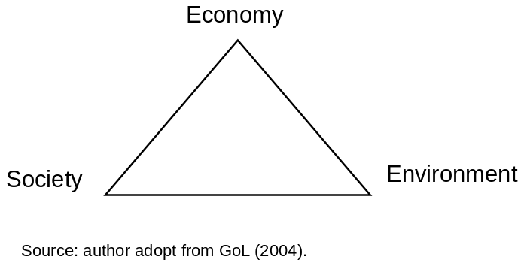

AWR (aquatic wetland resources) are important elements in the livelihoods of the Lao people, especially the poor. In considering tenvironmental and natural resource management issues that impact all economic sectors, the Lao government has undertaken some important policy and institutional measures to boost its capacity to manage its natural resources in a sustainable manner.

Several laws concerning natural resource and environmental issues have been passed in recent years. However, effective law enforcement has been hampered to a large extent by the absence of regulations and frameworks for such enforcement (Liemphrachanch 2005).

The main provision on wetlands is stipulated in the Land Law of 1997, which was amended in October, 2003. A wetland is defined in Article 23 as land which is under water or land in close proximity with water sources such as; underwater land, river banks, land formerly covered by water which has since dried up or land formed by a change or diversion of a waterway. Unfortunately, in Laos, there is no specific law or regulation on wetlands for their protection and management.

In practice, no land survey, measurement, or allotment of wetlands at local, regional or national levels have been undertaken. No national master plan for land has been put in place. Therefore, many rice-growing lands and marshes, particularly in areas surrounded by the big cities and towns like VC, have been converted to residential buildings, shopping malls, factories, etc., which result in a decrease in the direct and indirect economic values of the wetlands (Liemphrachanch 2005).

1.2 Institutional framework
In Laos, there are many ministries and agencies involved in environmental management and conservation, including the Ministry of Agriculture and Forestry (MOAF), Science, Technology and Environment Agency (STEA), National Environment Committee (NEC), and Water Resources Coordination Committee (WRCC). However, none of these have a formal framework for the coordinated management of wetlands in Laos. The responsibilities and interests of the government agencies involved in wetland management are different between agencies. Therefore, there exists some conflicts between them in terms of managing wetlands plus their mandates are to various extents, overlapping, unclear, and unrealized (Liemphrachanch 2005).

2.0 Overview of Boung Kiat Ngong (BKN)

BKN has an area of 3,000 ha and is located at Phathomphone district, Champasak Province. BKN provides natural fish-breeding, rice cultivation, aquatic vegetation, and also flood control, purification of wastewater, CO2 capture/storage etc. There are about 13 villages using the natural resources of BKN, 8 of which (about 11,530 persons) highly rely on BKN for their livelihoods.

BKN is fresh water wetland which has rich biodiversity, supporting 31 bird species (3 bird species are included in endangered species list). It supports more than 70 animal species and more than 528 herbs for traditional medicine (Louanglath, 2008). In addition, BKN is one of the most important eco-tourism spots in the south of Laos.

The importance of the ngongs biodiversity has been recognized by GOL and the wetland is the first site in Lao PDR to be nominated for recognition under the Ramsar Convention on Wetlands of international importance.

There are a number of direct and indirect pressure on Boung Kiat Ngong which will have significant effects on livelihood in medium and long term (Louanglath, 2008). Two of the main pressure are discussedbelow;.
1) There is a lack of flat land in the vicinity for rice cultivation and the demand for converting wetland to agriculture land is high. Converting wetlands to rice cultivation would lead to a decline in fish stocks which is main income for poor people living in the area. As medium and rich household have funds for investing on converting wetland to agriculture land, this is likely to lead to conflict between poor and rich in commodity.

2) Recently the peat extraction in Boung Kiat Ngong is also important factor for declining biodiversity.

Converting or developing wetlands may have significant adverse impacts on wetland resources and livelihood, therefore such development in wetlands needs to be considered more carefully before reaching a decision.

Data collected by IUCN in 2008 on the direct economic benefits of BKN to communities living around the wetland. This data indicates that these communities rely heavily on the natural resources of the ngong and its ecosystem interms of daily subsistence and produce for cash generation.See some data of socio-economic situation in some village around BKN in appendix 2-1 to 2-5.

3.0 Economic Value of Wetland and Valuation Tools
3.1 Economic value of wetland
The economic value of wetland ecosyetems wetland can be divided into four categories: direct (DV), indirect (IV), option (OV) and existence (EV) values (Figure 3-1). Direct benefit (DV) refers to physical use of resources such as timber, firewood, wild foods, NTFP, etc. Indirect values (IV) refer to ecosystem services such as watershed protection, carbon sequestration, landscape, water quality and supplies. Option values (OV) refer to future economic options such as industrial, pharmaceutical, recreational applications. And existence values (EV) refer to intrinsic worth, regardless of use such as landscape, aesthetic, heritage, bequest and culture (IUCN, 2006). However, most policy makers consider only the direct economic value of ecosystems , and neglecting the other values leads them to underestimate the true economic value of the wetland. This is one of the factors that has caused the loss of biodiversity in many developing countries, including Lao PDR.

Total Economic Value (TEV) = DV + IV+ OV + EV

As there are many economic values which have different methodologies to estimate economic values of wetland.

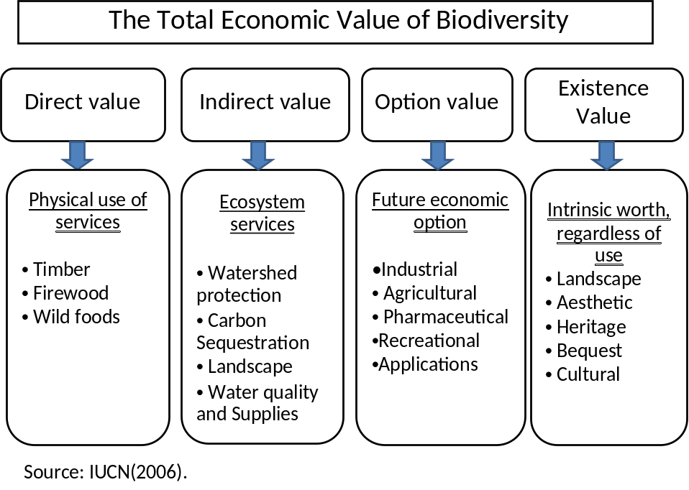
Figure 3-1. Total economic value of wetland

3.2. Reviews of Wetland Valuation in Laos and Neighboring Countries
There are many studies of the value of wetlands in developed and developing countries around the world but the majority focuses on the value of direct benefits. There are various type of wetland and they used various methodologies to estimate economic values of wetland (table 3-1 and 3-2).

There are few studies on wetland valuation in Laos. There are some studies of wetland valuation in some ASEAN countries. Chong (2005) assessed the economic value of the Stoeng Treng RAMSAR site in Cambodia in order to improve wetland management. This study found that wetland resources were essential to livelihood, worth an average of US$ 30,000 per household per year. Fishery was more valuable to poorer households than the wealthier ones. Janekarnkij and Mungkung (2005) assessed the economic value of the Krabi river estuary RAMSAR site as a marine tourism center by using market prices and the benefit transfer approach.

There are also some studies concerning wetland values in Laos. Gerrard (2004) measured the economic value of TLM by using secondary data from Vientiane Capital (VC) and identified the impact of urban planning on the ecosystem in TLM. The economic value of TLM (direct and indirect values) was under US$ 5 million per year to the people in VC. This study demonstrated that the loss of wetland resources would have a large impact on local communities, in particular on the poorer households relying on the wetland’s resources. Phonvisai (2006) also measured the economic value of TLM by reviewing the environmental impact of existing land use changes and policies on the wetland’s ecosystem values. This study found that the changes in land use were increasing and these had a negative impact on wetland resources.

In addition, author have studied economic values of wetland and the linkage between economic value of wetland and irrigation in Laos as follows. Kyophilavong (2008) estimated net benefits of That Luang Marsh and comparison of wetland resources and rice cultivation. It shows that wetland resources have higher benefits than rice cultivation. Kyophiavong (2006) summarized economic value of wetland in Laos. The author collected more than 40 economic values of wetland. Kyophilavong (2005) reviewed economic value of wetland for conservation and wise used in Laos. This document prepared for IUCN which was document for RAMSAR convention. Bhattarai et al (2006) studied the smallholder irrigation impacts on wetland livelihoods and aquatic resources use in remote villages in southern Laos.
(table 3-3)

Table 3-1. Summarizing the methodology for estimating economic values of wetland
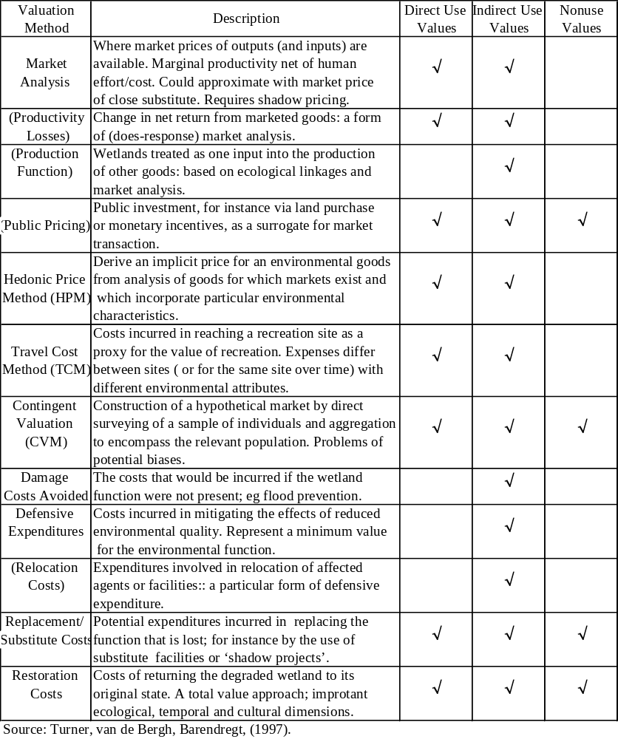

Table 3-2. Summary Information for Wetland Valuation Case Studies (1)
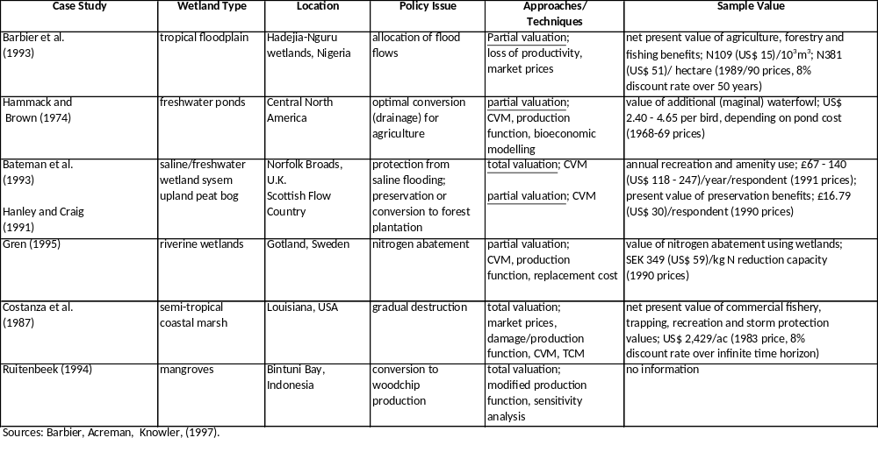

Table 3-3 Summary Information of Wetland Valuation Case Studies (2)
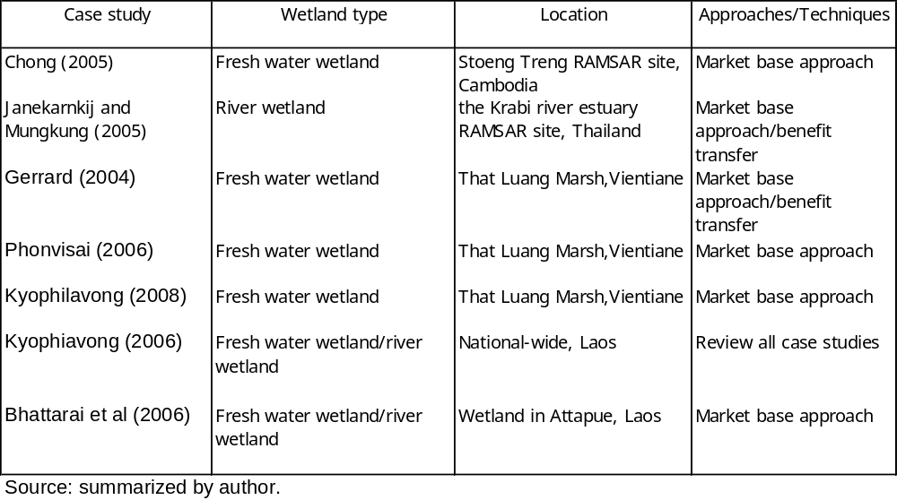
Table 3-4. Summary Information for Wetland Valuation Case Studies (3)
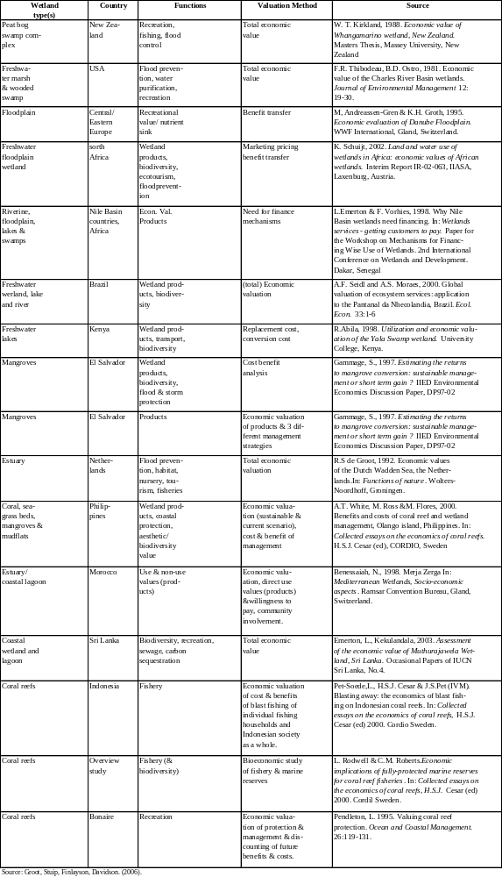

3.3. Reviews of Relevant Wetland Valuation Methodologies
There are various approach for estimating economic value of wetland. Meta-analysis/benefit transfer is popular approach in developed and developing countries when policy makers confront with time and budget constraints. It uses secondary data and existing studies for this approach. State Preference Methods which called Choice Modelling and Contingent Valuation Method (CVM) are also popular approach for wetland valuation. This approach is budget on primary data collection and can be used when time and budget is available. Travel cost method (TCM) is used primary data base to estimate the willing to pay (WTP) the cost of visiting a recreational site. In addition, market price approach is popular approach for estimating direct benefit of wetland. The more details of each approach is shown as follows.

1. Meta-analysis/benefit transfer
The meta-analysis is widely use for benefit transfer in various areas in developing and developed countries around the world in many areas. The theory and practice of meta-analysis is well documented by Bergstrom. and Taylor (2006);Muthke et al. (2004); and Ready Richard (2004). Bergstrom. and Taylor (2006) discuss the general theory behind and practice of the emerging use of meta-analysis for benefits transfer and attempts to statistically measure systematic relationships between an environmental good or service and attributes and human population and sample characteristics, and characteristics of the good or service itself. The results shows that meta-analysis may prove to be a useful tool for benefits transfer in particular applications if it is carefully conducted following systematic protocols for model development, data collection, and data analysis and interpretation.

There are a large documents of meta-analysis for wetland valuation. Brander et. al (2006) conducting meta-analysis of the valuation literature include tropical wetlands(e.g., mangroves), estimates from diverse valuation methodologies, and a broader range of wetland services (e.g., biodiversity value). Authors collected over 190 wetland valuation studies, providing 215 value observations. Authors find that socio-economic variables, such as income and population density, that are often omitted from such analyses are important in explaining wetland value. Woodward and Wui (2001) used results from 39studies to conduct meta-analysis to predict wetland’s value based on previous studies. The result shows that the prediction of a wetland’s value based on previous studies remains highly uncertain and the need for site-specific valuation efforts remains large. Brouwer et.al (2000) presents a meta analysis for the use and non-use values generated by wetlands across North America and Europe. The study assesses the socio-economic values attributable to the hydrological, biogeochemical and ecological functions provided by such complex environmental assets. Moeltner and Woodward (2009)applies functional Benefit Transfer via Meta-Regression Modelling to derive valuation estimates for wetlands in an actual policy setting of proposed ground water transfers in Eastern Nevada. The results indicate that economic losses associated with the disappearance of these wetlands can be substantial and that primary valuation studies are
warranted.
Benefit transfer is widely use for estimating non-market value. Kirchhoff et al (1997) develops a methodology to evaluate the performance of direct benefit transfer and benefit function transfer and applies the methodology to two pairs of similar non-market amenities. Empirical results indicate that benefit function transfer is more robust than transfer of average site benefits. Wilson and Hoehn (2006) overview state-of-the-artand science of environmental benefit transfer and to assist in the design and reporting of future benefit estimation research. Compiling the insights of thirty-two international experts from seven countries, the special issue reviews the latest developments in transfer techniques, as well as ongoing efforts to standardize and validate them.
Benefit transfer used for various non-market value estimation. Ready Richard (2004) use result of simultaneous contingent valuation surveys conducted in five different European countries. Consistent inter-country differences in willingness to pay to avoid ill health episodes could not be explained by measurable differences in individual characteristics. The result shows that international transfer of unit values resulted in an average transfer error of 38% due to measurable differences among countries in health status, income and other demographic measures.

Rozan anner, (2004) use use the benefit transfer to compare result of CVM which conduct in two sites of case study,Strasbourg (France) and Kehl (Germany) in order to test the reliability of the benefit transfer method. The result shows that test is that the valued good is the same in both cities, which means that the transfer is an ‘‘intra-site’’ transfer. Piper et al (2001) use the benefit transfer technique is analyzed for the development of a rural water supply system and guidelines for successful benefits transfer are presented. Benefit transfer appears to provide reasonably accurate estimates of natural resource benefits if a broad based benefit model is used. The benefits-transfer-based estimates are accurate as long as a model based on data from a wide variety of conditions is used or the model is based on data from a very similar region. The wide-based data modelling approach has the greatest practical application. These findings are based upon contingent valuation data obtained from four sites in the western USA. Barton (2002) estimate willingness-to-pay (WTP) for improvements in coastal water quality were conducted in the town of Jaco and city of Puntarenas on the Pacific Coast of Costa Rica and also compare with benefit transfer. Results also show that census-type socio-economic site characteristics are necessary, but not sufficient to explain site-specific differences in WTP. The trade-offs in designing valid and reliable benefit transfer studies with transferable results are discussed. Bergstrom et al (1999) overviews current use of benefit transfer in United States and Canada. It show that benefits transfer techniques are subject to a number of conceptual and empirical limitations, these techniques are widely applied by government agencies as input into economic assessments of public policies and projects.

The validity of benefit transfer methods were discussed by Muthke et al. (2004); Rosenberger et. Al (2006); Brouwerroy and Spaninks (19990) and Kristoferssondadi and Navrud (2005). Muthke et al. (2004) analyze the forecasting quality of benefit transfer by applying a rigorous t-test – also referred to as accuracy-t-test – that takes into account testing errors which were made in previous surveys. Rosenberger et. Al (2006) discusses three potential sources of errors that affect the accuracy of benefit transfers. The result shows that measurement error occurs when researchers' decisions affect the transferability of measures of value or as the result of sampling. Generalization error occurs when a measure of value is generalized to unstudied sites or resources. Publication selection bias occurs when the objectives for publishing research limit benefit transfer applications of research outcomes. Criteria for selecting which research results are published may be at odds with the needs of benefit transfer practitioners.

Brouwerroy and Spaninks (19990) provides further empirical evidence of the validity of environmental benefits transfer based on CV studies by expanding the analysis to include control factors which have not been accounted for in previous studies. The function transfer approach is valid in one case, but is rejected in the 3 other cases investigated in this paper. The result provide further evidence that in the case of statistically valid benefits transfer, the function approach results in a more robust benefits transfer than the unit value approach. Kristoferssondadi and Navrud (2005). exams the the validity of environmental benefit transfer. Authors argue against this assumption on the basis of theory, which clearly indicates that environmental benefits should be assumed to vary from context to context. In addition, author suggest the use of equivalence testing as a more appropriate and a clear compliment to the shortcomings of classical tests.

2. Choice Modelling/CVM
Choice modelling is used for estimating the economic value of wetlands by their attributes. There are some studies using Choice modelling for estimating economic attributes of wetland. Pate and Loomis (1997) estimate willingness to pay for three programs of wetland management using choice modelling. The results indicate that distance affected WTP for two of the three programs (wetlands habitat and wildlife, and the wildlife contamination control programs). Carlsson et al (2003) estimates economic values of wetland attributes using choice modelling .The result shows that the attributes increase and decrease citizens perceived value of wetlands. Using a random parameter model we find that biodiversity and walking facilities are the two greatest contributors to welfare, while a fenced waterline and introduction of crayfish decrease welfare. Birol Ekin et at (2006) aims to assist policy makers in formulating efficient and sustainable wetland management policies in accordance with the Ramsar Convention and the European Union Water Framework Directive, by providing results of a valuation study on the Cheimaditida wetland in Greece. A choice experiment is employed to estimate the values of changes in several ecological, social and economic functions that Cheimaditida wetland provides to the Greek public. The results reveal that there is considerable preference heterogeneity across the public and on average they derive positive and significant values from sustainable management of this wetland.

Contingent Valuation Method is popular tool for estimating economic value of wetland. The discussion of using CVM for valuation of ecosystem are discussed by Spash (2000) and Loomis John et. al (2000). Spash (2000) addresses a current issue in environmental valuation by supplementing contingent valuation analyses with an exploration of the motives behind willingness to pay responses, including zero bids and refusals to answer. Loomis John et. al (2000) asked a dichotomous choice willingness to pay question regarding purchasing the increase in ecosystem services through a higher water bill.The result shows that households would pay an average of $21 per month or $252 annually for the additional ecosystem services.

There are some studies of using CVM for estimating economic value of wetland.Wattage et al (2008) use contingent valuation method (CVM) to estimate the total economic value of wetland conservation in Sri Lanka. Estimated median WTP is Rs. 264.26, which is thought reliable when considering average income in the community. The analytic hierarchy process (AHP) was used to separate use and non-use values from the total value. Results show that non-use values are a significant component in the elicited WTP value, of between 45-55%.

The bias and validity of CVM also were discussed by Kanninen (1995) and Morrison et al. (2000).Kanninen (1995) investigates and compares the biases inherent in single-bounded and double-bounded maximum likelihood estimation procedures and examines how they react to various bid designs and sample sizes. Then it examines the presence and identification of “outliers” in binary choice data and how these outliers influence estimation. Morrison et al. (2000) identifies the payment vehicle bias in contingent valuation studies. The most commonly used approach for determining whether payment bi a sexists is to use tests of convergent validity. It is demonstrated that simple tests of convergent validity can be ineffective in diagnosing the existence of payment vehicle bias. Payment vehicle bias is found to occur because of differences in the coverage of payment vehicles and doubts about payment being one-off..

3. Travel costs
Travel cost method (TCM) is that if an individual is willing to pay
(WTP) the cost of visiting a recreational site then he should value that site at least as much as what he paid to visit it. The travel cost approach is different from the contingent valuation method (CVM) in term of real markets rather than in hypothetical circumstances by changing in behaviors

Farder (1988) and Shrestha et al. (2002) use the Travel Cost Method (TCM) to estimate recreation value of wetland. Farder (1988) uses Travel Cost Method (TCM) to estimate recreation value of Louisiana coastal wetlands. The result shows that depending on the time cost value used, the average capitalized value ranged from $36 to $111 per acre. Shrestha et al. (2002) estimate recreational fishing value of the Brazilian Pantanal is measured using travel cost method (TCM). The economic values of recreational fishing in terms of consumer surplus (CS) are derived using non-linear and truncated models. The results shows that the CS values from $540.54 to $869.57 per trip resulting in the total social welfare estimate range from $35 to $56 million.

4. Market price
Market price method is the simplest and most straight forward way of finding out the value of wetland goods because we know directly what they consume and sell of wetland goods such as fish, animals, and other. This method use questionnaire to collecting data about market price of buying and salling wetland goods.

For example, catching fish from wetland sale in local market. We could estimate all wetland goods and product for wetland- Direct value of wetland by market price approach Haab and McConnell (2003); Emerton(1998);

There are also other method for estimating economic values of wetland such as Replacement cost method, Damage cost methods, Hedonic Price approach, and Valuing change in production. More details of this methods see in Haab and McConnell (2003); Boyer and Polasky (2004); Barbier et al (1997); Kisten Kuke Brander. (2004);and Springate – Baginski et al (2009).

In sum, there isvarious approach to estimate economic value of wetland including direct and indirect benefits which deferred from time line and budget. However, due to budget and time constraints, author will employ market base approach for estimating direct benefit of wetland and meta-analysis/ benefit transfer for estimating indirect benefit of wetland.

4.0 Valuation Tools Design for BKN
There are mainly three methodologies for estimating economic values of BKN. Firstly, market based analysis is used for estimating direct and indirect values of BKN. This approach will followe Kyophilavong (2008) and others. Secondary data is collected from various institutions for this method.
Second is benefit transfer techniques is used to estimate indirect benefit of BKN, we will followed the steps and guideline from Rolfe and Benenett (2006) and others.
Thirdly, Contingent Valuation Method (CVM) is used for estimating the biodiversity value/endanger species value in BKN. This approach will followe the studies of Thuy (2007), Do (2007), and others. The ecological functions in BKN and proposed methodology is shown in table 4-1.

Table 4-1. Ecological function in BKK and valuation tools
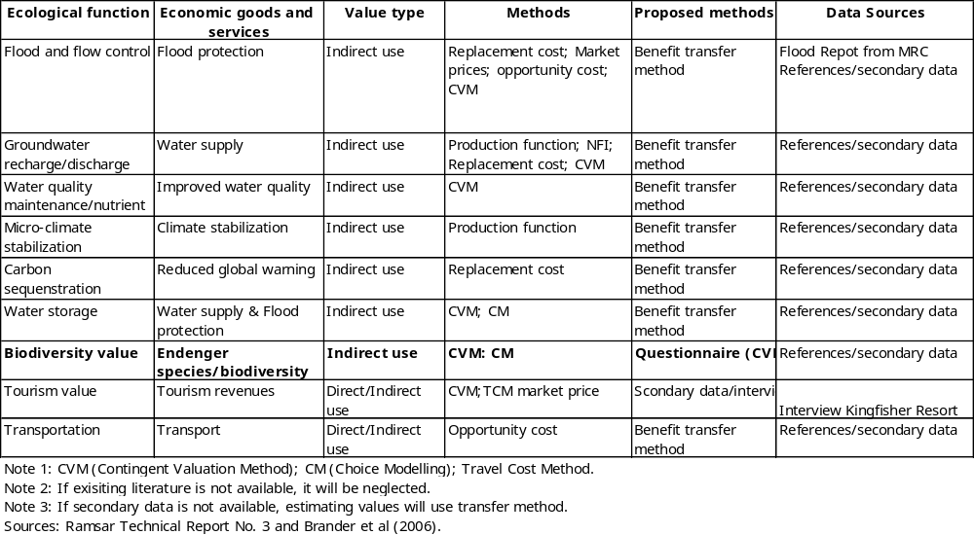
There are various benefit of wetland such as culture value Option value (pharmaceutical value) and existence value (landscape, aesthetic, heritage and culture) and also transportation value, but due to lack of such value in existing literature, these value will explain thought the description.

4.1. Market base methodology
Normally, this approach is used for estimating direct economic values of wetland. The questionnaire will be used to ask household how much they collect or sell fish, non-fish products, etc from the wetland. Please see questionnaire in appendix 1. However, this questionnaire will not for this study, but it might be used for other studies. We will use secondary data from IUCN to estimating the coefficient of direct benefit of wetland and will gathering key information from head of villagers and key information on provincial level to estimate direct benefit of BKN.

Net benefit of rice production
In order to estimate net benefit of rice production in BKN, firstly we have to estimate cost for rice production. Secondly, we estimate the average rice yield from the household survey data. Thirdly, we estimate the average net benefit of rice production from cost and output (yield) in previous step. Fourthly, we estimate the total rice area in dry and rain season from key village information. The equation for estimation the net rice production in BKN is shown as follows. It is important to note that we do not include cost in our studies due to budgets and time constraints.

(3.1) 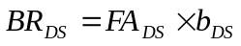
(3.2) 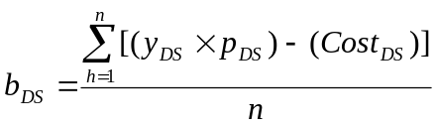
(3.3) Cost = Irrigation + Material + Labour + capital

Where;
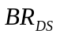: Total net benefit from Rice cultivation (kip)
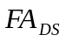: Total farm area (ha)
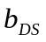: Average net benefit from rice per household (kip/ha)
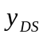: Yield of rice (kg/ha)
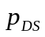: Price of rice (kip/kg)
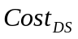: Cost of rice cultivation (kip)
Number of sampling household

Fish and non-fish
There are various values from AWR; however in this study, we focus on direct use value of AWR. The direct use value of AWR refers to fish and non-fish and vegetation. In order to estimate net benefit from AWR in the BKN, first we estimate cost of AWR, second we estimate the output of AWR from household survey data. Third, the average net benefit per household is estimated by cost and production of AWR. Fourth, we estimate the total household number that collecting AWR in each village from key village information. The equation for estimating benefit from AWR are as follows:

(3.4) 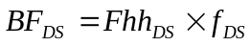
(3.5) 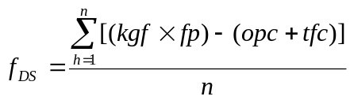
Where;
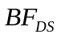: Total net benefit from catching fish (kip)
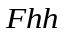: Total number of household catching fish (kip)
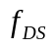: Net benefit of fishery per household (kip)
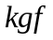: Amount of fish per household (kg)
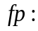 Fish price (kip)
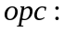Opportunity cost (kip)
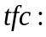 Fishery tools cost (kip)
Number of sampling household

(3.6) 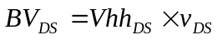
(3.7) 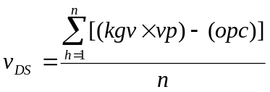
Where;
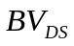: Total net benefit from collecting vegetation (kip)
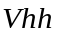: Number of vegetation household
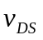: Average net benefit of vegetation per household (kip)
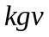: Amount of vegetation per household (kg)
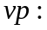 Vegetable price (kip/kg)
Opportunity cost (kip)
Number of sampling household
Aquatic vegetation
To estimate the total net benefit from vegetation in BKN, first we estimate average net benefit from collecting vegetation per household from household survey data. Second, we estimate number households who collect vegetation in BKN from village key information. The equations for estimation total net benefit from collecting vegetation are as follows:

(3.8)
(3.9)

Where;
: Total net benefit from collecting vegetation (kip)
: Number of vegetation household
: Average net benefit of vegetation per household (kip)
: Amount of vegetation per household (kg)
Vegetable price (kip/kg)
Opportunity cost (kip)
Number of sampling household
Eco-tourism benefit
I will also estimate eco-tourism benefit in BKN. The income which involve with eco-tourism will be asked to household. In addition, eco-tourism benefits from investor also estimated.

4. 2. Benefit Transfer Technique
Benefits transfer refers to the use of existing benefit estimates in a different but similar context compared with the original study that generated the benefit estimates. Benefits transfer techniques include fixed value transfer, expert opinion and value estimator models.

A benefit transfer process for environmental values normally involves the transfer values from a source site (The subject of a valuation study) to a target site. Four main ways of performing a benefit transfer process for this purpose is shown in Table 4-2

Table 4-2 Examples of transfer methods
Transfer method | Description | Example | Valuation technique Used
Single point value transfer | A single value is transferred without adjustment from source study to target site | A rainforest protection value of $50 persons is transfer from case study A to site B | Outcome of CVM often used for this purpose
Marginal point value transfer | A single value that allows For site differences is transferred | A rainforest protection value of $2/hectare/ person is transfer from case study A to B. The value are adjusted for the site of area protected | Part – worths of CM can be Used for this purpose. Some CVM results can also be adjusted for this purpose, but value may not be rigorous unless multiple CVM studies are available
Benefit function transfer | A valuation function is transferred, allowing adjustment for variety of site differences | A rainforest valuation function that involves several attributes is transfer from case Study A to site B | Models from CVM studies can be used for this purpose. Key advantage is that t allows for Automatic adjustment with variation in attribute levels
Meta value analysis | Results of several studies are combined to generate a pooled model | Result from studies A,X,Y and Z are pooled to estimate a value for site B | Can involve outcomes from both CVM and CM experiment
Source: Rolfe and Benenett (2006).
When conducting benefit transfer, it is very crucial to consider factors as follows.
- The site are almost identical
- The same population is involved
- The extent of change being considered it the same in both source ad target cases
- The ` frame` of the source study matches the `frame` of the target study; and
- The initial valuation study has been performed rigorously and accurately.

Benefit transfer involve greater differences between site and target studies, indicating that more analysis. In order to gain high validity, the key stage of benefit transfer excercise is shown in table 4-3. We will follow Rolfe and Benenett (2006)’s stages to estimate economic value of wetland using benefit transfer method.

Table 4-3. Stage is a benefit transfer exercise
# | Stage | Notes
1 | Assess target situation
2 | Identify source studies available and select benefit transfer type | Transfer type largely dependent on source studies available
3 | Assess site differences | - Identify if BT possible  - Identify basis for BT adjustment
4 | Assess population difference | (a) Identify if BT possible  (b) Identify basis for BT adjustment
5 | Assess scale of change in both cases | - Identify if BT possible  - Identify basis for BT adjustment
6 | Assess framing issues(scope, scale, instrument, payment vehicle, payment length, willingness to pay or willingness to accept format used, use versus non - use | - Test if source study is appropriate for BT  - Identify basis for BT adjustment
7 | Assess statistical modeling issues | - Identify appropriateness of model in source study  - Identify basis for BT adjustment
8 | Perform benefit transfer process
Source: Rolfe and Benenett (2006).

In cases where it is not appropriate to perform benefit transfer directly between a source and target study, it may be possible to use adjustment factor to make the transfer process more accurate.

In order to estimate benefit of wetland from benefit transfer method, it needs various data on socio-economic characteristics of household around BKN, hydrology function, ecosystem function. If these data is not available, we will use secondary data from national level. The coefficient using in benefit method will be driven from relevant references Brander et. al (2006); Woodward and Wui (2001); Brouwer et.al (2000); and Moeltner and Woodward (2009).
4.3 Contingent Valuation Method (CVM)
Contingent Valuation Method (CVM) will be used for estimating biodiversity value of BKN. The explanation of CVM, questionnaire design, sampling technique is as follows:

- Model
The most important value of a wetland is derived from non-use benifits, and other benifits. As these values do not have a market price, they are difficult to estimate. Therefore, wetland benefit cannot be measured with market data on prices and quantity demanded.
The Contingent Valuation Method (CVM) was chosen for this study because wetlands are considered a public good.

The CVM is popular method for estimate non-use values in particular total values. The CVM reveal respondent’ maximum Willingness to Pay (WTP) to obtain some degree of environmental improvement or to avoid a loss. The implementation of valuation of wetland biodiversity is followed the work of Whitehead (1990); Do (2007).

Implementation of the CVM requires construction of hypothetical market that contain a description of the proposed policy that will effect the wetland resource. After the hypothetical Market is established direct valuation question are presented to survey respondents. Open-ended questions typically ask, “What is the Maximum amount of money you would pay for preservation of the wetlands resource ( as described in the contingent market)? ” Close-ended (dichotomous choice) valuation question ask.
The CVM survey design must be appropriate to measure wetlands biodiversity value for this study. Willingness to Pay (WTP) to avoid development of a wetland for converting wetland to agriculture land and surface peat extraction is the benefit measure. Willingness to Pay (WTP) to void development is found by analyzing household choice under two options. In option 1 (current situation), the household income is reduced by the amount of its willingness to pay for preservation, and the wetland biodiversity is preserved. In the second option (development option), the household maintains income, but the wetland is developed for agriculture land and surface peat extraction. The dollar amount that make a household indifferent between the two policy situation is the estimate of Willingness to Pay (WTP).
The unit of analysis for this study is the household. To define willingness to pay consider a typical household that gains utility ( happiness) from its income and the availability of wetland resources
U=U(Y.Q) (1)
Where U(.) is the utility function , Y is household income, and Q is the wetland resource If the wetland resource is faced with development due to surface coal mining, The two policy situation are defined by.
U(Y- WTP,Q⁰) = U(Y,Q’’) (2)
Where WTP is willingness to pay , Q0 is the original amount of wetland preserved , and Q” is the amount of wetland preserved after surface coal mining . The difference between Q0 and Q” is the amount of wetland mined. Willingness to pay is the maximum amount of money house hold are willing to give up to maintain The wetland at Q” and their utility level at U(.). Willingness to pay includes both use and nonuse values.
- Questionnaire Design
The questionnaire was drafted based on some key sources: interviews in government agencies, group discussions and literature. The draft of question is designed based on literature as shown in appendix 2.

Before the formal survey, pre-tests will conducted each with 20 samples (Pakse: 10 and Attapue:10) in 1-2 November . Based on the feedback from pre-tests, the questionnaire will be revised accordingly.

The questionnaire consisted of four parts: (1) WTP to preserve biodiversity; (2) the Socio-economic characteristics of residents; (3) Perception on common problems facing the country; (4) Perception on environmental problem; (5) Perception on endangered species ;(6)Perception on the impact of declining biodiversity and endanger species.

In the willingness to pay (WTP) part of survey, the interviewee will be asked the maximum WTP for converse endanger species (bird) in BKN. Before asking this question, the important of conservation of endangered species (birds) in BKN will be explained. Secondly, details of a theoretical project to conserve endangered species (birds) in BKN will be explained. Thirdly, the impact of this theoretical project on improving biodiversity and their benefit will be described. Fourthly, the details of payment vehicle will also explained. In addition, pictures of current endangered species (birds) will be also attached in the questionnaire and shown to interviewees during interviews.

In this study, we will use the open-end question to obtain a household’s willingness to pay for maintaining biodiversity in BKN. Before ask the CVM questionnaire, we will explain the difference between current situation (option 1) and possible improvement or maintain of biodiversity (option 2). This question will ask how much the Maximum Willingness to Pay for protecting biodiversity of BKN.

- Sampling

This survey conducted from 8-13 November in 4 provinces (Atthapue, Champasak, Savannakhet and Vientiane) and foreign tourist who visit south of Laos.
Interviews were limited to 20-30 minutes. To ensure validity of data collection, the stratified random sampling technique will be use which based on population data from province. See sample frame in table 4-4. Firstly, we divided target district into urban and rural. Secondly, urban and rural divided into rich, medium and poor household based on key information (head of village). In order to avoid bias on gender issues in sampling collection, we conducted during weekday and weekend.

This survey carried out by students and faculty lecturers from the Faculty of Economics and Business Management and the National University of Laos. Before conduction survey, interviewer including lecturers and students were trained in order to understand of objectives of project and questionnaire. Two sampling collection techniques will be used and involved: face-to-face interviews and resident focused on head of household. The students and lecturers were trained before conducting the survey.

Table 4-4 Sampling frame for CVM survey
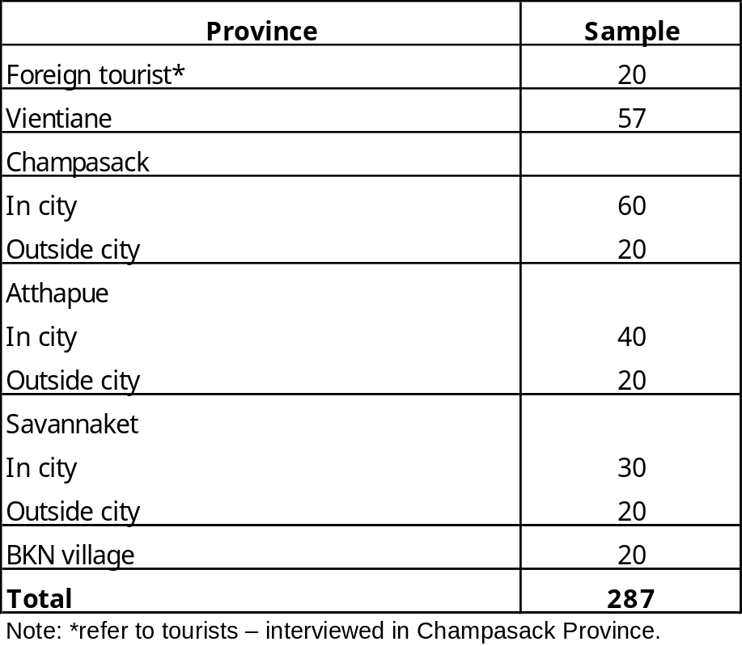

5.0. Economic Value of BKN
5.1 Market base approach
Due to limited budget and time, secondary data and results from IUCN (2008) is used for estimating direct benefit from BKN. IUCN conducted survey in 6 villages around BKN. Each village had 20 samples which stratified to rich, medium and poor households. It is important to note that this direct benefit focus only in big fish, small fish and eel which ignore other aquatic water resources such as crab, shrimp, and fox. In addition, this study ignores animals such as (mouse), insects and grass for feeding animal. Therefore, this result might be under-estimated.

The result is shown in table 5-1. The total income of fish and eel in 6 villages are 8.46 million US/year. Kiat Ngong village is one of the most villages which has highest direct benefit from BKN because Kiat Ngong village locates in BKN which has more advantages to access to BKN comparing to other villages.

Table 5-1. Direct benefit of BKN
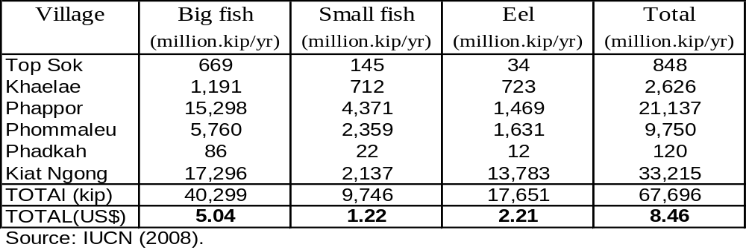
Note: Exchange rate (1US$=8000 kip)

5.2 Contingent Valuation Method (CVM)
Contingent Valuation Method (CVM) is one of the most popular non-market based approach. Implementation of the CVM requires construction of hypothetical market that contains a description of the proposed policy that will be effected the wetland resource. Empirical studies of CVM model is shown as follow.

Sep1. Model
This approach, implemented by means of surveys, aims to assess how individuals would hypothetically react to changes in environmental quality. In particular, it elicits from respondents how much they would be willing to pay to access improved environmental quality or avoid a hypothetical reduction in environmental quality.
Principle is simple. Assume that an individual's utility function before an environmental quality improvement is given by
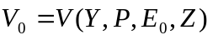

Where:
Y is income;
P is a price index;
Eo is the initial quality of the good or service;
Z is a vector of all other variables of concern.

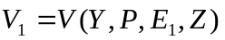After improving the quality of the good or service from E0 to E1, the individual’s utility becomes:

The individual's maximum willingness-to-pay (WTP) for the quality improvement can be defined by the equation:

We can solve the above equation for WTP:
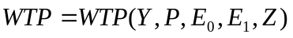

Step 2. Questionnaire Design
After CVM model is defined then next steps in questionnaire design. The design is following steps.
- The questionnaire was drafted based on some key sources: interviews in government agencies, group discussions and literature.
- Before the formal survey, pre-tests will conducted each with 20 samples(Pakse:10andAttapue:10) in 1-2 November
- Based on the feedback from pre-tests, the questionnaire will be revised accordingly.

In order to capture WTP and characteristics of respondents, the questionnaire consisted of four parts as follows.
(1) WTP to preserve biodiversity;
(2) the Socio-economic characteristics of residents;
(3) Perception on common problems facing the country;
(4) Perception on environmental problem;
(5) Perception on endangered species ;
(6)Perception on the impact of declining biodiversity and endanger species.
In the willingness to pay (WTP) part of survey, the interviewee will be asked the maximum WTP for converse endanger species (bird) in BKN appendix 2). in order to make respondent reveal appropriate WTP, in WTP part, it is important to explain situation change from conservation and payment vehicles as follows.
- the important of conservation of endangered species (birds) in BKN will be explained.
- details of a theoretical project to conserve endangered species (birds) in BKN will be explained
- the impact of this theoretical project on improving biodiversity and their benefit will bedescribed.
- the details of payment vehicle will also explained.
- 5. pictures of current endangered species (birds) will be also attached in the questionnaire and shown to interviewees during interviews.

Step 3. Sample collection
It is important to make sample to represent whole samples. Sample collection has been done as following steps.
- The city is divided into urban and rural
- Urban and rural is divided into block based on road and characteristics of city (see in appendix 2).
- In each block, household is divided into three types of household (rich, medium and poor) which based on interviewer’s perception.
Sample is stratified into block then divided into rich, medium and poor based on interviewers’ perception.

The sampling size is shown in table 5-2. Total sampling for estimating is 287 samples which divided by Champasack provice (80 samples), Atthapue province (60 samples), Savannakhet province (50 samples), BKN village (20 samples), foreign tourist (20 samples) and Vientiane capital (57sample).

Table 5-2. Sample size

5.3 Results/discussion
The mean of WTP is shown in table 5-3. The average of WTP of whole sampling is 4.14US$/household/month. The highest WTP for conserving BKN’s biodiversity is
19.8 US$ for foreign tourist and second highest WTP is 2.6US$ from Vientiane. Surprisingly, WTP in BKN village which use more resources of wetland comparing with others has low WTP for conserving biodiversity, 0.30US$/household/month. The two main reasons for high WTP for foreign tourist and Vientiane is as follows. First is income of respondent. Foreign tourist and resident in Vientiane have relative higher income comparing with residents in other province. Second is the perception in importance of wetland land. Conservation of wetland has gained awareness in foreign countries and Vientiane resident also realize the important of wetland (That Luang Marsh) for food protection and waste water treatment. In on the other hand, BKN village has low WTP due to mainly low income.
Table 5-3. Mean of WTP by province
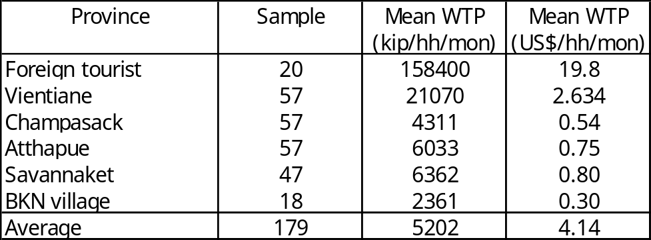

The total of WTP is equivalent to mean of WTP multiple with number of household in each province (table 5-4). The total of total WTP (biodiversity value) is 6 million US$ or about 2170 US$/ha/year. It shows that biodiversity of value is high.

Table 5-4. Total of WTP results/discussion by province
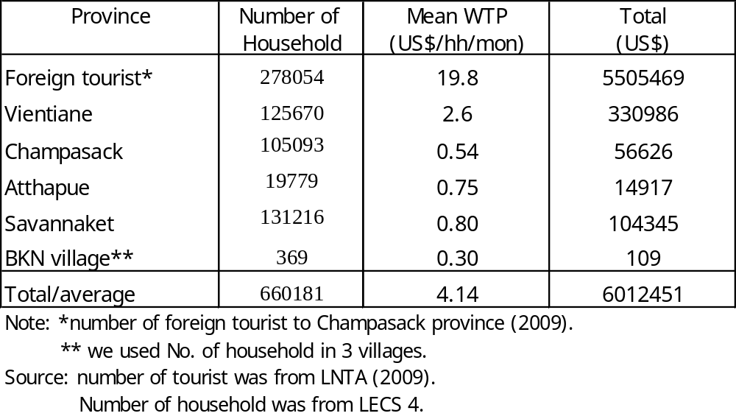

5.4. Benefit Transfer Method (BTM)
Benefit transfer method (BTM) is popular method when time and cost are constraints. BTM is using previous studies results for estimating value in other site. There are mainly two approaches in BTM; One site approach and function approach. However, function approach is popular and validity comparing one site approach. Next, function approach is explained as follows.

Y= f ( X, C , …..)
Y : value of wetland (US$/ha)
X: Function of wetland
C: Characteristics of wetland
In order to implement BTF for function approach, following steps must be undertaken.

Step 1. Review studies on wetland
- Excess to online Journal for reviews studies of wetland using BTM.
- There are more 15 studies on benefit transfer of wetland around the world.
- Choosing most relevant literature for transferring value of wetland for Lao context.

Step 2. Choosing literature to conducting BTM
More than 15 studies of BNF of wetland is found. However, Brander et al (2006) and Schuyt and Brander (2004) are chosen for using estimating wetland value for Laos.
Brander et al (2006), The empirics of wetlandvaluation: A comprehensive summary and a Meta-analaysis of the literature, Environmental & Resources Economics (33).
Schuyt and Brander (2004), The economic values of the world’s wetland, WWF.
There are two main reasons for choosing Brander et al (2006) and Schuyt and Brander (2004). Firstly, sample size of two studies are large and including a lot of sample from Asia. Secondly, two studies contain various benefits of wetland (table 5-5 and 5-6). The regression of economic value of wetland from meta-analysis is shown in table 5-7.
Table 5-5. Choosing literature to conducting BTM
Source: Brander et al (2006)

Table 5-6. Choosing literature to conducting BTM
Source: Brander et al (2006)

Table 5-7. Estimating Results (regression) (1)
Source: Brander et al (2006)

Table 5-7. Estimating Results (meta-regression) (2)
Source: Brander et al (2006)

Based on result of meta-regression (table 5-7), characteristics of BKN such as type of wetland value has been in putted in regression then results was estimated for economic value of BKN. The result of wetland value of BKN is shown in table 5-8. The indirect value of BKN which including flood control, water supply and water quality is US$ 4195/ha/year, in indirect value, flood control has highest share (916 US$/ha/year).

Table 5-8. Result of Estimating Indirect Value
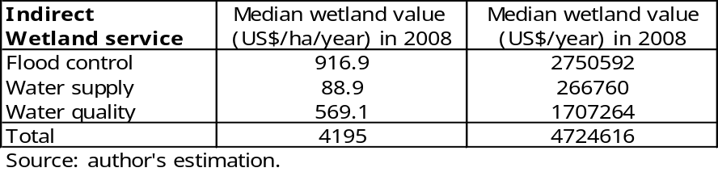

5.5 Total Economic Value of BKN
Total economic value of BNK is summing of direct benefit (from IUCN), biodiversity of BKN (from CVM), and indirect value (from BNF). The total of economic value of BKN is 19 US$ million/year. Surprisingly. As expected, indirect value has highest share, account for 54% and direct value account for 43% in total value (table 5-9). Surprisingly, direct value (fish and non-fish animal) has high share in total economic value comparing with other (Barbier, Acreman, and Knowler, 1997; Janekarnkij and Mungkung, 2005; Kisten and Brander, 2004; Kyophilavong, 2008). It shows that BKN is playing very important role for local livelihood around BKN. The main reasons for high share of direct benefit are that BKN has rich biodiversity and geographic condition. BKN is very rich for fish, and the fish which catch in BKN is much more larger than other wetland. According to fishery expert, there are rich biodiversity and food for fish in BKN. Therefore, fish in BKN is larger than other wetland.
Biodiversity value is highest share in indirect value of BKN. It is show that BKN is playing important role for local and international level in term of biodiversity economic value. As this reason, BKN has been register in Ramsar site convention in 2010.

Table 5-9. Total economic value of BKN
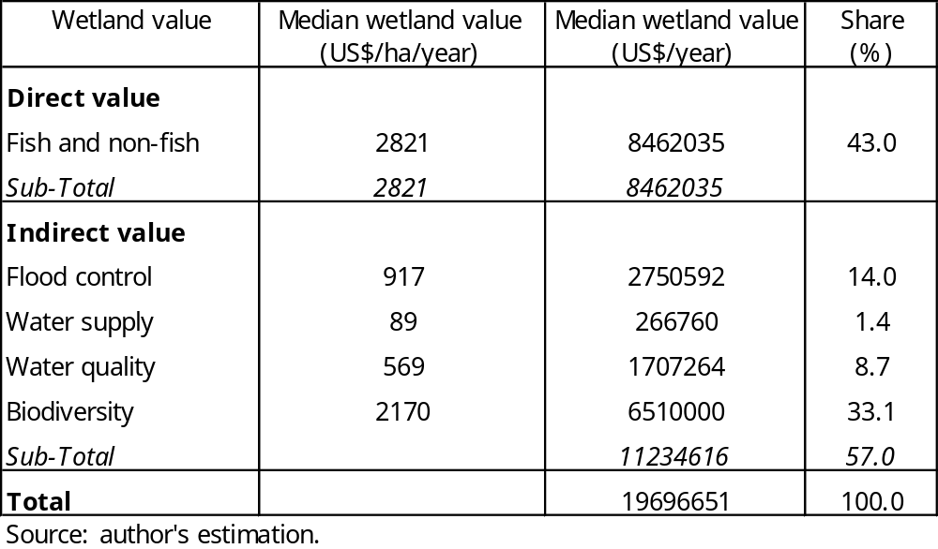

6. Conclusion
The main objective of this study is trying to estimate economic value of wetland (BKN) which useMarket base approach, Contingent Valuation Method (CVM) and Benefit Transfer Method (BTM). Based on this result, conclusion is drawn as follows.

Economic value of BKN is very high, account for about US$19 million/year. Surprisingly, direct benefit is playing important role in BKN and account for about 43% of total benefit. It is important to note that wide-range of benefit of BKN did not include in this study such as culture value, transportation value. From this study, it is clear that losing of BKN (converting BKN to other used) from other development seems to bring high cost for local people. Therefore, conservation and wide used of BKN is crucial for local livelihood and national level.

However, due to budget and time constraints, there are several weakness as follows. Firstly, estimating of direct value might be under-estimated. Secondary data from IUCN is used, this data ignore some direct benefit from BKN such as insects, animal and glass, etc. Secondly, the sampling of Asian wetland in meta-analysis (BNF) is quite small. Therefore, some value of BKN might be under-estimate true economic value of BKN. Thirdly, as CVM application is new in Laos, respondent might cause some bias during respond.

References

Barbier, E., Acreman, M., Knowler, D. (1997), Economic valuation of wetlands: A guide for policy makers and planners, Ramsar Convention Burea, Gland, Switzerland.

Bateman, I., et. Al. (2002), Economic Valuation with Stated Preference Techniques: A Manual. Cheltenham, UK: Edward Elgar.

Barton David N., (2002). Analysis The transferability of benefit transfer: contingent valuation of water quality improvements in Costa Rica, Ecological Economics 42, pp 147–164

Bergstrom. John. C., Taylor Laura O., (2006). Using meta-Analysis for Benefits Transfer: Theory and practice, Ecological Economics 60, pp.351-360

Bolt, Katherine., Ruta, Giovanni., Sarraf, Maria (2005), Estimating the Cost of Environmental Degradation – A Training Manual -, Environment Department Paper, Paper No. 1, World Bank.

Boyer, Tracy., and Polasky, Stephen. (2004), Valuing Urban Wetland: A Review of Non-Market Valuation Studies, Wetlands, Vol. 24, No.4, pp. 744-755.

Brander. Luke M., Florax, Raymond J.G.M., and Vermatt, Jane. (2006)
The Empirics of Wetland Valuation:A Comprehensive Summary and a Meta-Analysis of the Literature, Environmental & Resource Economics 33, pp. 223–250.

Brouwerroy J.,and Spaninks Frank A., (1990). The Validity of Environmen- tal Benefits Transfer: Further Empirical Testing, Environmental and Resource Economics 14, pp 95–117.

Brouwer. R., Langford I.H., Bateman I.J., andTurner R. K. (2003), A Meta-analysis of Wetland Contingent Valuation Studies, Business and Economic, p. 318

Birol Ekin, Karousakis Katia , Koundouri Phoebe , (2006). Methods Using a choice
experiment to account for preference heterogeneity in wetland attributes: The case of Cheimaditida wetland in Greece, Ecological Economics 60, pp.145-156

Bergstrom John C. and De Civita Paul , (1999). Status of Benefits Transfer in the United States and Canada: A Review, Canadian Journal of Agricultural Economics 47, pp 79–87

Chong. J. 2005. Valuing the Role of Aquatic Resources in Livelihoods: Economic
Aspects of Community Wetland Management in the Stoeng Treng Ramsar Site,

Cambodia. Technical Paper No. 3 on Water, Nature and Economics. The
International Union for the Conservation of Nature (IUCN). Colombo, Sri Lanka.

Carlsson Fredrik, Frykblom Peter , Liljenstolpe Carolina. (2003), Analysis Valuing wetland attributes: an application of choice experiments, Ecological Economics 47, pp. 95 – 103.

Do Thang Nam (2007), Impacts of Dykes on Wetland Values in Vietnam’s Mekong River Delta: A Case Study in Plain of Reeds, Research Report No. 2007-RR1, the Economy and Environment Program for Southeast Asia.

Emerton, L (1998), Economic tools for valuing wetlands in Eastern Africa, IUCN Eastern Programme, Economics and Biodiversity Programme.

Farber, S (1988), Value of Coastal Wetlands for Recreation: An Application of Travel Cost and Contingent Valuation Methodologies, Journal of Environmental Management JEVMAW Vol. 26, No. 4, p 299-312

Gerrard. P. 2004. Integration Wetland Ecosystem Values in Urban Planning:Th2
Cause of That Luang Marsh, LaoPDR. Working Paper. IUCN and WWF. Vientiane, Laos.

Gordon. C. 1996. An Inventory of the Wetlands of Lao PDR. IUCN. Bangkok, Thailand.

Groot, R., Stuip, M., Finlayson., Davidson, N. (2006), Valuing wetland: Guidance for
valuing the benefits derived from wetland ecosystem services, RAMSAR Technical Report No. 3, Gland, Switzerland.

Haab, Timothy, C., and McConnell, E. (2003), Valuing Environmental and Natural Resources – the Econometrics of Non-Market Valuation, Edward Elgar Publishing, UK.

IUCN (2006), Can Lao PDR afford not to invest in conserving its biodiversity?
Exploring the need for innovative financial mechanisms, Vientiane, Laos: The World Conservation Union (IUCN).

IUCN (2008), BCI Socio-Economic Study (Draft summary report), IUCN Laos,
Vientiane, Laos.

Janekarnkij. P and N. Mungkung. 2005. Assessing the Value of Krabi River Estuary Ramsar Site: Conservation and Development. Working Paper. Kasetsart University. Bangkok, Thailand.

Kisten Schuyt, Kuke Brander. (2004). The Economic Value of the World’s Wetlands, WWF.

Kyophilavong (2008), The Impact of Irrigation on Aquatic Wetland Resources: A Case Study of That Luang Marsh, Laos, Research Report, the Economy and Environment Program for Southeast Asia.

Kyophilavong (2006), People and Aquatic Ecosystems: Wetland Valuation and Inventory, Consulting Report, Mekong River Commission (MRC).

Kyophiavong (2005), Economic Valuation of the Conservation and Wise Use of Wetland in Lao PDR, IUCN.

Kirchhoff Stefanie, Colby Bonnie G., and LaFrance Jeffrey T., Evaluating the Performance of Benefit Transfer: An Empirical Inquiry, Journal of environmental Economics and Management 33, pp.75]93-1997

Kristoferssondadi and Navrud Stalek, (2005). Validity Tests of Benefit Transfer – are We Performing the Wrong Tests., Environmental and Resource Economics 30, pp 279–286

Kanninen J. Barbara, (1995). Bias in Discrete Response Contingent Valuation, Journal of Environmental and management 28, pp. 114-125

Louanglath, K. (2008), Data and economic value of Boung Kiat Ngong, Division of Agriculture and Forestry in Champasak province. (in Lao).

Liemphrachanch. K. 2005. Legal and Policy Measures Related to Wetlands in Lao PDR. Working Paper. Mekong Wetlands Biodiversity Programme (MWBP). IUCN. Vientiane,

Loomis John , Kent Paula , Strange Liz , Fausch Kurt , Covich Alan , Analysis Measuring the total economic value of restoring ecosystem services in an impaired river basin: results from a contingent valuation survey,

Muthke. Thilo., and Holm-Mueller.Karin, (2004). National and Interna- tional Benefit Transfer Testing with a Rigorous Test Procedure, Environmental & Resource Economics 29 ,pp. 323–336

Morrison M . D., Blamey R. K. and Bennett J. W., (2000). minimizing Payment Vehicle Bias in Contingent Valuation Studies, Environmental and Resource Economics 16, pp. 407–422,

Moeltner. Klaus., and Woodward. Richard. (2009). Meta-Functional Benefit Transfer for Wetland Valuation: Making the Most of Small Samples, Environ Resource Econ 42, pp.89–108

Phonvisai. P. 2006. Urban Wetland and Ecosystem Assessment and Management: Case Study of That Luang Marsh, Vientiane, Laos. Master’s Degree Thesis. School of Environment, Resources and Development. Asian Institute of Technology. Thailand.

Piper Steven and Martin Wade E., (2001) Evaluating the accuracy of the benefit transfer method: A rural water supply application in the USA, Journal of Environmental Management 63, pp.223–235
Pate Jennifer, Loomis john, (1997). The effect of distance on willingness to pay values: a case study of wetlands and salmon in California, Ecological Economics 20, pp.199-207.

Rolfe. John., and Benenett. Jeff. (2006). Choice Modelling and the Transfer of Environmental Values, Edward Elgar Publishing, UK.

Ready Richard, Navbrud stale, Daybatt, Dubourg Richard, Machado Fernando, Mourato Susana, Spanninks Frank and Xose Vazquez Rodriquez Maria, (2004). Benefit Transfer in Europe: How Reliable Are Transfers between Countries?, Environmental & Resource Economics 29, pp. 67–82.

Rozan anner, (2004). Benefit Transfer: A Comparison of WTP for Air Quality between France and Germany, Environmental & Resource Economics 29, pp. 295–306.

Rosenberger. Randall. S., Stanley Tom D., (2006) Measurement, generalization, and publication: Sources of errors benefit transfers and their management, Ecological Economics 60, pp.372- 378

Shrestha,
Ram K. , Seidl, F., and Moraes, Andre. S. (2002), Value of recreational fishing in the Brazilian Pantanal: a travel cost analysis using count data models,
Ecological Economics, Vo. 42, Issues.1-2, pp. 289-299.

Spash Cliv L .(2000). Special issue social processes of environmental valuation Ecosystems, contingent valuation and ethics: the case of wetland re-creation, Ecological Economics 34, pp. 195–215

Springate - Baginski, O., Allen,D. and Darwall,W.R.T.(2009). An Integrated Wetland Assessment Toolkit: A guide to good practice. Gland. Switzerland: IUCN and Cambridge, UK:IUCN Species Programme.

Turner, R. K., van de Bergh, J.C.J.M., Barendregt, A. (1997), Ecological-economic analysis of wetlands: Science and Social Science Integration, Paper for Global Wetland Economic Network (GWEN).

Thuy Truong Dang (2007), Willingness to Pay for Conservation of the Vietnamese Rhino, Research Report, the Economy and Environment Program for Southeast Asia.

Wattage Premachandra, Mardle Simon, (2008). Total economic value of wetland conservation in Sri Lanka identifying use and non-use values, Wetlands Ecol Manage16,pp.359–369.

Woodward. Richard T., Wui Y., and Ong-Suhk. (2001) The Economic Value of Wetland Services: a Meta-Analysis, Ecological Economics 37 , 257–270 .

Wilson Matthew A., Hoehn John P., (2006). Valuing environmental goods and services using benefit transfer: The state-of-the art and science, Ecological Economics 60, pp 335-342.

Whitehead, John, C. (1990), Measuring Willingness to Pay for Wetlands Preservation with the Contingent Valuation Method, Wetlands,Vol.10, Number.2, pp.187-201.

Appendix 2-1. Poverty rates among households
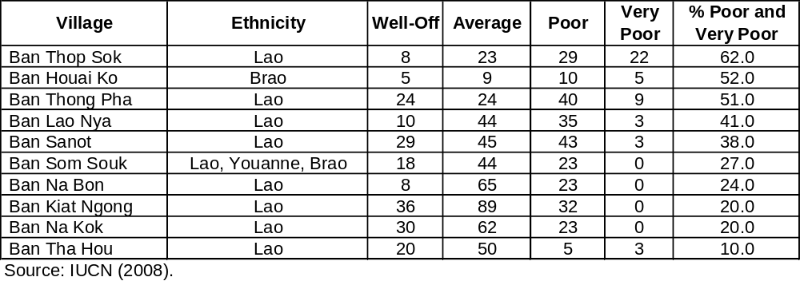

Appendix 2-2. Contribution of livelihood components to cash income
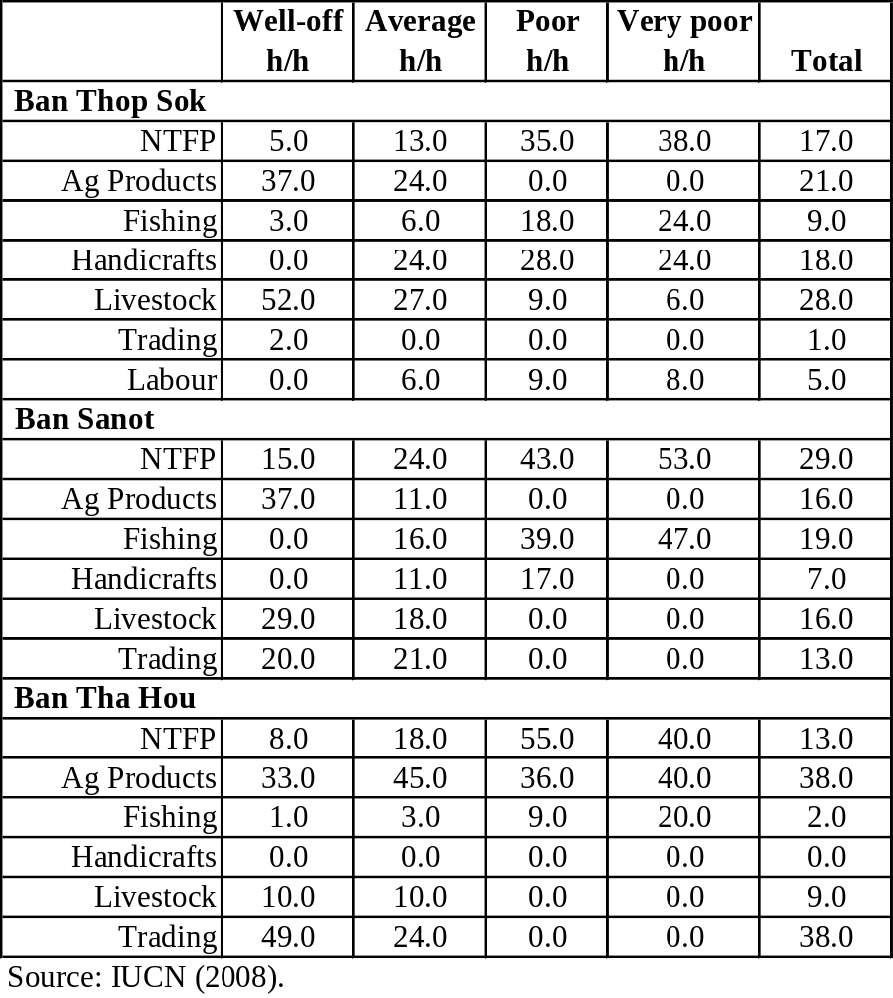

Appendix 2-3. Wetlands use in Bueng Kiat Ngong
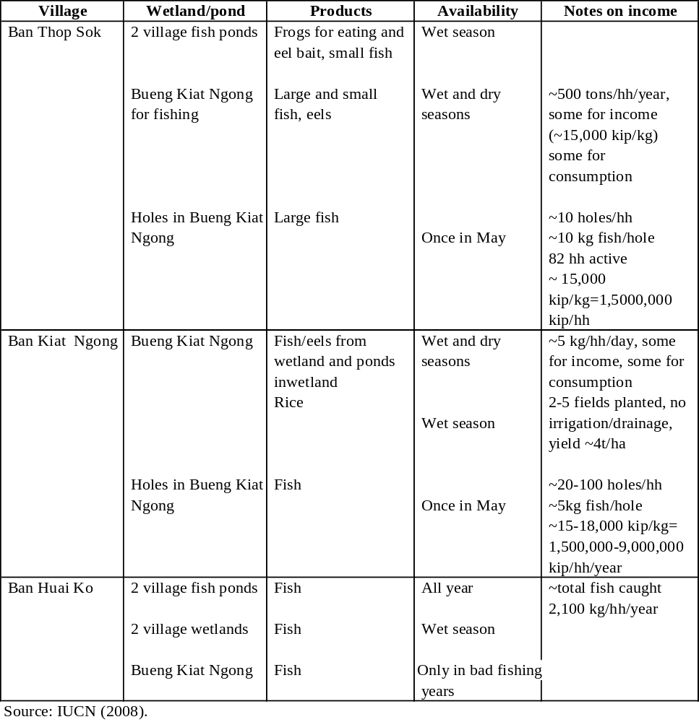

Appendix 2-4. Average income from fishing
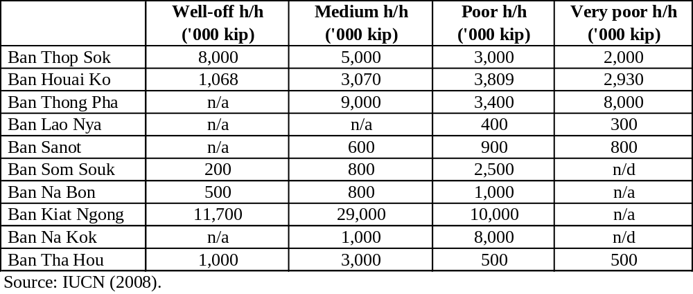
Appendix 2-5. Disaggregated livelihood strategies
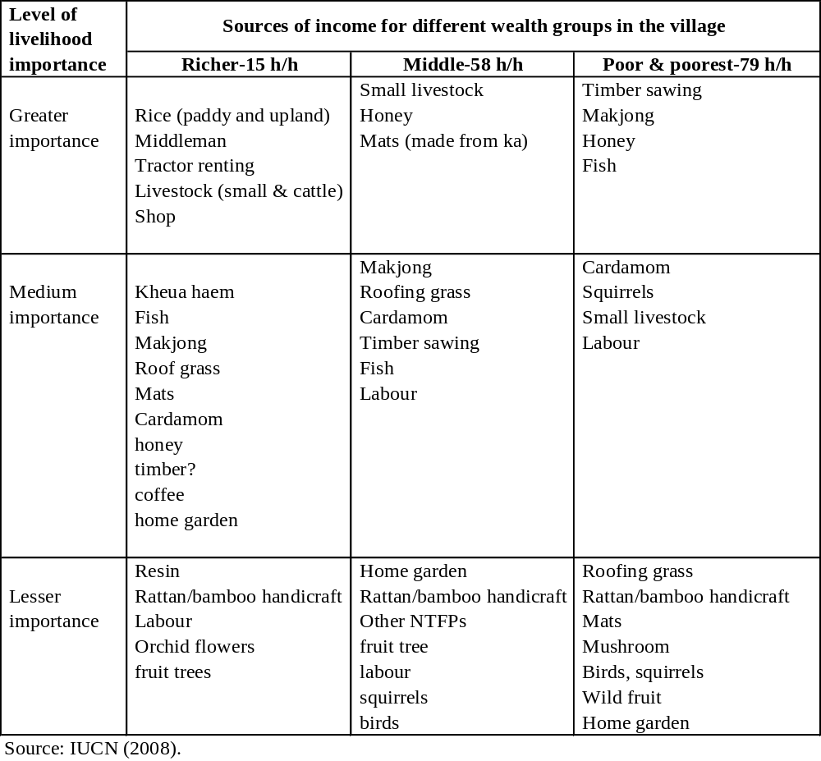

Appendix 1: Households Survey Questionnaire for estimating direct economic value of BKN (Preliminary Draft)
1. General Particulars
A. Name of village:_____________________________________________________
B. Name of District:____________________________________________________
C. Name of Interviewer:_________________________________________________
D. Date of Interview:_____/dd______/mm________/yy
2. Family (who is living with household now)

No. | Relationship | Age | Sex | Education | Occupation
 |  | (year) |  | (year) | Primary |  | Secondary
 |  |  |  |  | Name | Income per month | Name | Income per month
1
2
3
4
5
6
7
8
9
10
Note1: Primary school (5years), Secondary school (3year), High school (3year), college (2-3yea
3. Land holding (around the BKN)
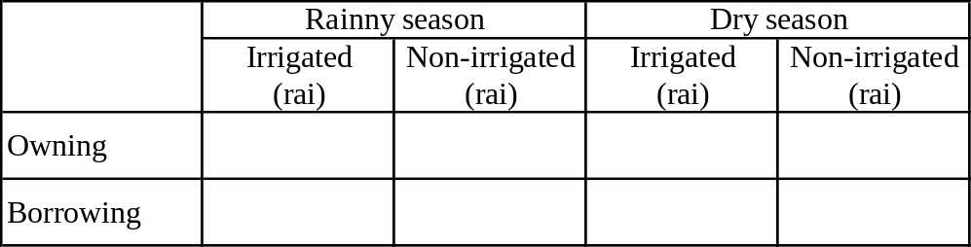

4. Assets (agriculture machine)
No. | Asset | Number
1 | Big tractor
2 | Small tractor
3 | Power tiller
4 | Pump-set
5 | Bullock cart
6 | Boat
7 | Other1:
8 | Other2:
Note: if it is blank, it means "don’t have"

6. House
1. Your house is:
1) Owning 2) government 3) borrowing from (cousin, etc) 4) other

2. Type of house:
1) One floor concrete 2) two floor concrete
3) One floor wood 3) two floor wood
4) Two floor concrete and wood

3. Distance of house from BKN
1) ____________minutes by walking

4. Distance of house from main road
1) ____________minutes by walk

8. Catching fish
Rain season
From …… to ……..

 | How much do you catch?
No | Type of fish | Months | day/month | Amount
 |  | in year |  | (kg/day)
1
2
3
4
5

Dry season
From …… to ……..
 | How much do you catch?
No | Type of fish | Months | day/month | Amount
 |  | in year |  | (kg/day)
1
2
3
4
5

In the ponds
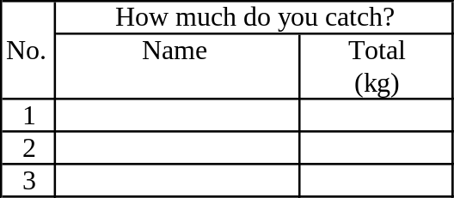

9. Catching non-fish
Rain season
From …… to ……..
 | How much do you catch?
No | Name non-fish | Months | day/month | Amount
 |  | in year |  | (kg/day)
1
2
3
4
5

Dry season
From …… to ……..
 | How much do you catch?
No | Name non-fish | Months | day/month | Amount
 |  | in year |  | (kg/day)
1
2
3
4
5

In the ponds
 | How much do you catch?
No. | Name | Total
 |  | (kg)
1
2
3

10. Collecting aquatic vegetable
Rain season
From …… to ……..
 | How much do you collect?
No | Name of vegetable | Months | day/month | Amount
 |  | in year |  | (kg/day)
1
2
3

Dry season
From …… to ……..
 | How much do you collect?
No | Name of vegetable | Months | day/month | Amount
 |  | in year |  | (kg/day)
1
2
3

11. Rice production

During dry season
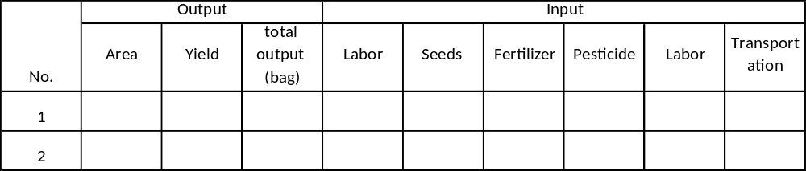

During rainy season

12. Other income

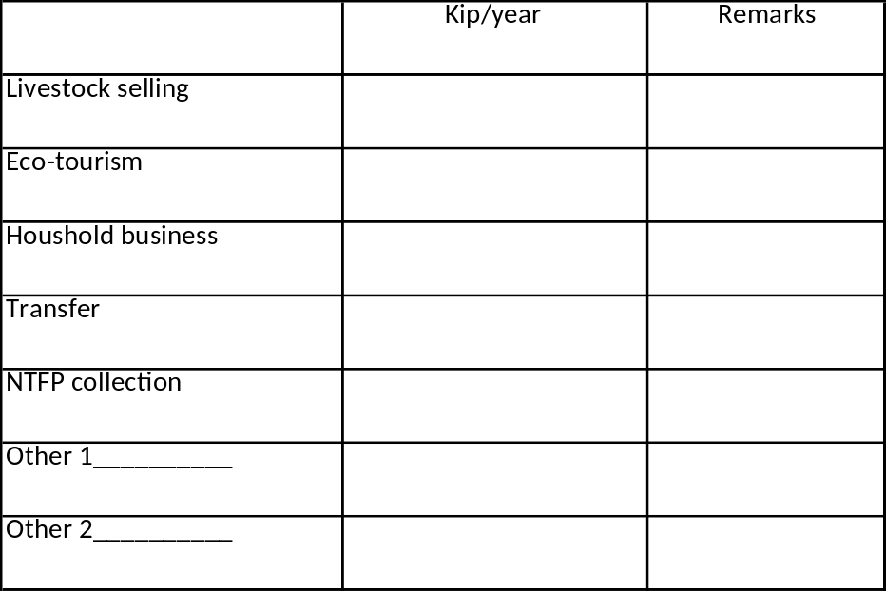

Thank you

Appendix 2 Estimation of Willingness to Pay (WTP) to Conservation of Biodiversity in Boung Kiat Ngong, Laos.

First, I would like to introduce myself. I am a 4th year student at the Faculty of Economics and Business Management, National University of Laos. The main purpose of this survey is to estimate the Willingness to Pay (WTP) to conserve biodiversity in BKN which includes a number of endangered bird species. This data from this survey will be used only to estimate the economic value of BKN in Laos.

1.0. Willingness to Pay (WTP) to conserve Endangered Species (bird)

BKN has an area of 3,000 ha, and is located at Phathomphone District, Champasak Province. Boung Kiat Ngong (BKN) provides natural fish-breeding habitat, water and wetlands for rice cultivation, aquatic vegetation, and also flood control, purification of wastewater, CO2storage, ground water recharge and other services. Thirteen villages are located around BKN and villagers use the ngong for fishing, gathering aquatic animals (eg. snails and insects) and vegetation and growing rice on the margins of the ngong.

BKN is fresh water wetland which has a rich biodiversity. The nong supports 31 birth species (what do you mean by birth species) (3 birth species are included in extinct list –endangered rather than extinct?). It supports more than 70 animal species and more than 528 herbs for traditional medicine. In addition, BKN is one of the most important eco-tourism spots in the south of Laos.

There are various direct and indirect pressure on Boung Kiat Ngong which have significant effects on livelihood in medium and long term. Firstly, the district authority has a plan to convert to wetland to agriculture land. This activity will lead to the lose of biodiversity in BKN. Secondly, surface peat extraction activities are planned which will also threaten the treated wetland’s biodiversity. These two activities will have significant adverse impacts on the wetland and livelihoods of local communities especially on the poor who are highly depend on wetland resources.

Suppose that in order to cope with this problem, the Department of Forestry started a program called “Wetland Biodiversity Preservation Fund in BKN”. This project would provide funding to BKN in terms of operation costs and recurrent management cost for wetland biodiversity conservation. In addition, the program would also cooperate with villagers and commodities? for protected wetland biodiversity.

If this project is implemented, it would maintain biodiversity and protect endanger species (birds) and maintain the current situation at the ngong. Implementing this project will require a large amount of funding, and unfortunately, the authorities do not have enough money. Therefore, we would like to hear your opinion.

How much is your Maximum Willingness to Pay (WTP) for this Wetland Biodiversity Preservation Fund ……………..kip/month for 10 years. Your payment would be added to your electric fee. (Please remember that your payment will decrease the amount of money you will have to spend for other things). This Wetland Biodiversity Preservation Fund will be implemented only if the majority of Lao people vote for it.
Figure 1. Location of BKN

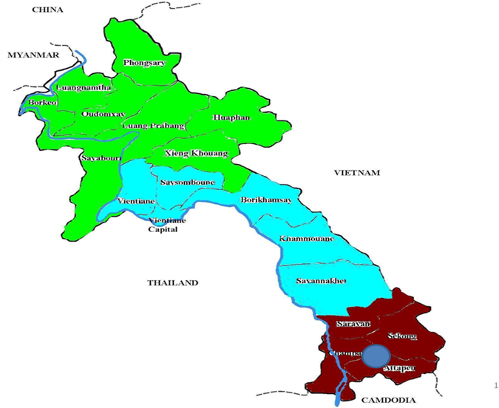
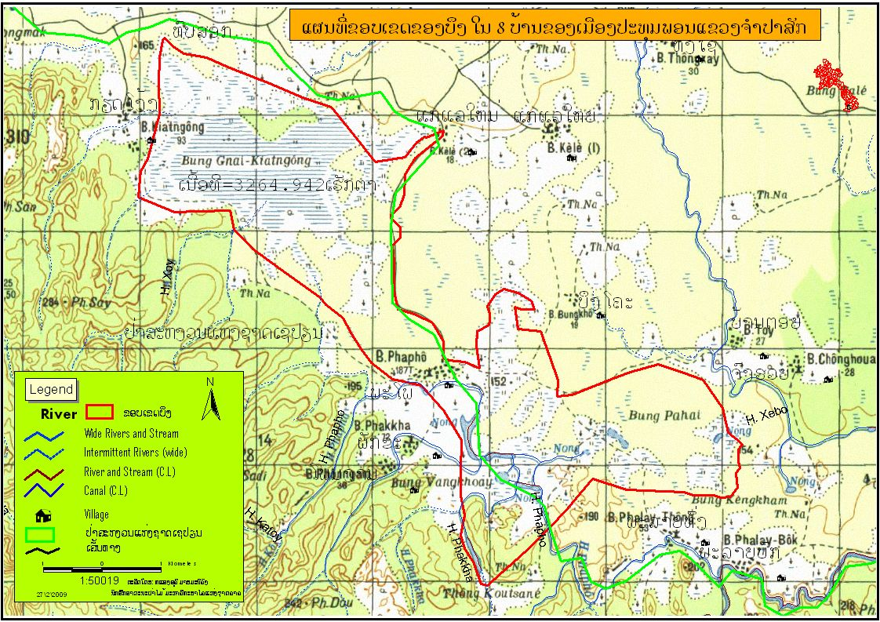

Figure 2. Biodiversity/endangered species

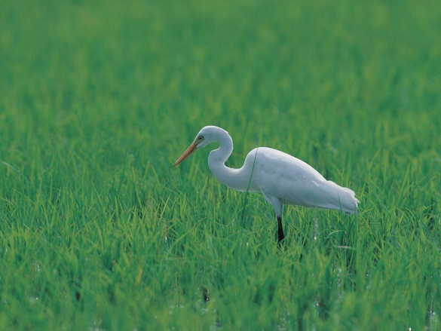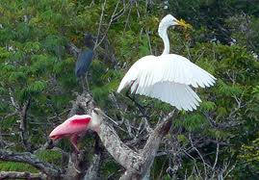
Name: Nok Yang in BKN

1.1 What is your main reason for paying for this program? (choose two answers)
1/ Improve biodiversity and protect endanger species in wetland
2/ Can mitigate climate change
3/ Contribute money to authorities with budget constraints to protect wetland biodiversity
4/ Indirect benefits of conservation wetland biodiversity are high
5/ This is initiative can lead to more protection for biodiversity in Laos
6/ Other reason………………………………………………………………..

  - What is the main reason for not paying for this project? (choose one answer)
1/ Declining biodiversity and endanger species in BKN is a minor problem for me
2/ Do not have money, other expenditures are high
3/ Someone else (Lao government) should pay
4/ Someone else (Lao people- who benefit from wetland) should pay
5/ Do not have confidence in the implementation of this project
6/ Do not have confidence that this project will happen
7/ Other reason……………………………………………………

2.0 Information of responder
1. Your sex 1/ Female 2/ Male
2. Your age………………years old
3. Your education: 1/ No education 2/ Primary school 3/ Secondary school
4/ High school 5/ College 6/ University 7/Higher than University 7/ Other
4. Your main job: 1/ Government/city officer 2/ Private/state-owned company employee 3/ Retailer 4/ Self-employed 5/ Farmer/gardener
6/ University student/ student 7/ Housewife 8/ Construction Worker
9/ Unemployed 11/ Other………………………………………………
5. Salary (main job): …………………………………US$
6. Name of country………………………………………………
7. Number of time visiting Laos: 1/ First time 2/ Second time 3/ Third time
4/ More than fourth time

8. Social status 1/ Single 2/ Married 3/ Other
9. Number in family…………persons
10. Number of children in your family (less than 10 years old)………..persons

3.0 Perception on Common problems facing the country
What is the most problems of our country facing now? (choose one answer)
1/ Economic problem 2/ Poverty 3/ Education 4/ Health 5/ Crime
6/ Governance 7/ Infrastructure 8/ Environment 9/other …………………..

4.0 Knowledge on Boung Kiat Ngong
Do you know Boung Kiat Ngong? 1/yes 2/ no

Do you know that Boung Kiat Ngong has rich biodiversity? 1/yes 2/ no

5.0 Using Boung Kiat Ngong
Do you use Boung Kiat Ngong for fishing, collecting animal, woods, vegetables, grass, and other ?
1/yes 2/ no

In the past, have you ever used Boung Kiat Ngong for fishing, collecting animal, woods, vegetables, grass, and other?
1/yes 2/ no

6.0 Perception on Environmental Problem
What is the biggest environmental problem facing facing by our country ?
1/ Air pollution 2/ Water pollution 3/ Solid waste 4/ Deforestation 5/ Tariff problem 6/ Soil erosion 7/ Climate change 8/ Endanger species 9/ Soil erosion
10/ Other …………………………..

7.0 Perception on the impact of declining biodiversity and endanger species
1. What do you think about declining biodiversity/endangered species in wetland areas?
1/ Very serious 2/ Serious 3/ No problem 4/ Don’t know

8.0 Province, district and village information
Province…………………………………………………………………………………
District……………………………………………………………………………………
Village……………………………………………………………………………………

9.0 Interviewer information
Name: …………………………………………………………………………………………..
Sex: 1/Male 2/Female
Age: ……………………………………………………………………………………
Phone number…………………………………………………………………………
Interview date …………………………………………………………………………
Time……………………………1/weekday 2/weekend

Note on interview…………………………………………………………………………

…..…………………………………………………………………………………………..

…..…………………………………………………………………………………………..

Appendix3: Wetland inventory in Laos*

MEKONG RIVER.
DESCRIPTION OF LOCATION: The Mekong flows through provinces of
Louangnamtha,Bokeo, Oudomxay, Xayabury, Louangprabang, vienttiane, Vientiane prefecture, Borikhamxay, khammuane, Savanakhet, saravane and Champasack.
WETLAND TYPE: Perennial river, pool in perennial rover in Asia (after the Yangtze and the Yellow Rivers in China), seasonally flooded forest, seasonally grassland, and reverie banks, beaches and bars.
NAM NGUM RESERVOIR
Description of Location: Some-sixty five kilometers north of Vientiane and fifteen kilometers east of Route 13.
AREA: The reservoir has an area of 450 square kilometers when at maximum capacity. At low levels the water area is considerably reduced, for example, at 196 meters ASL surface area is 230 square kilometers. At the usual working height of 212 meters ASL the area is 370 square kilometers.
WETLAND TYPE: Multi-purpose reservoir (main purposes are electricity generation and flood control).
NAM HOUM RESERVOIR.
Description of Location: Approximately twenty seven kilometers north of Vientiane and five kilometers west of Route 13.
AREA: Approximately four square kilometers.
WETLAND TYPE: Reservoir for irrigation.
NAM SOUANG RESERVOIR.
Description of Location: Approximately forty Kilometers north of Vientiane and four kilometers west of Route 13.
AREA: Approximately ten square kilometers.
WETLAND TYPE: Reservoir for irrigation.
NAM NGUM RIVER WETLAND.
Description of Location: The valley/floodplain of the Nam Ngum River between the Nam Ngum with the Makong. north northwest, north and northeast of Vientiane City.
AREA: The region in which the wetlands. Are situated has an area of around 250 square kilometres, though the actual area of wetlands is less than this.
WETLAND TYPE: Freshwater lakes and ponds, oxbow lakes, permanent and seasonal reservoirs, perennial and seasonal rivers, freshwater marsh, irrigated and rain-fed rice paddy.
THAT LUANG/SALAKHAM MARSH.
Description of Location: On the eastern edge of Vientiane city, in the Districts of Xaysetha and Hatxayphong.
AREA: Approximately twenty square kilometres.
WETLAND TYPE: Freshwater marsh, aquaculture ponds, seasonal flooded grassland, seasonally flooded scrubland, peat scrubland.
NONG CHANH.
Description of Location: in the southeastern part of Vientiane city, in Sisattannak District of the Vientiane prefecture.
AREA: About twelve hectares when water level is 167 m ASL and 23 hectares at 168 m ASL
WETLAND TYPE: There is some difficulty in defining the wetland type of Nong Chabh. In principle it is a freshwater lake, since a significant portion of its area is a water body with no rooted vegetation lake. However, this lake area is fragmented by area rooted vegetation (freshwater marsh) and completely covered by floating vegetation.
NONGNIA(NAONGNGA)(PAKSANE AREA).
Description of Location: Approximately nine kilometres northwest of paksane (Paxan), between the Mekong River and Route 13. The site lies within the boundaries of the village of Ban kouay/ Ban Hin Lat.
AREA: The total area of the site, taking into account the surrounding marshland is approximately 0,75 square kilomatres.
WETLAND TYPE: Permanent lake, marsh, floating vegetation mats.
NAM KADAN WETLANDS.
Description of Location: North of Route 13 approximately 15 kilomayres directly east of pakxan (paksane).
AREA: The total area containing wetlands is a bounty fifty square kilomatres, of which more than halt is seasonal or permanent wetland.
The total area of the Nam Kadan basin is 82 square kilomatres, of which 51 square kilomatres is below 160 m ASL, and of this 6 square kilomatres is below 150 m ASL.
WETLAND TYPE: Permanent and seasonal freshwater lake, pond, marsh and stream.
NAM SA WETLANDS.
Description of Location: of Location North of Route 13 approximately 28 kilomatres directly east of paksane (pakxan).
AREA: The total area containing wetland is about sixty square kilomatres of which around one-third may be seasonal or permanent wetland .
The total area of the Nam sa basin is 239 square kilomatres, of which 58 square kilomatres is below 160 m ASL, and of this 4 square kilometres is below 150 mASL.
WETLAND TYPE: Permanent and seasonal freshwater lake, pond, march, river and stream.
NAM THON WETLANDS.
Description of Location: in the catchments of the Nam Dua/nam thon system, between Highway 13 and the Mekong River.
AREA: The wetlands are in two location, one near Highway 13 ()r
Nongboua wetlands) with an area of around 20 square kilomatres, the other (Nam nongnaxeng wetland )near the Mekong with an area of around eight square kilomatres
WETLAND TYPE: Permanent and seasonal freshwater lakes and ponds, freshwater marshes, and seasonal flossed areas.
NAM HINBOUN (BAN HINBOUN TO BAN PHAHANG)
Description of Location: The section of the Nam NAM HINBOUN Between Ban
Hinboun where Route 13 crosses the river and Ban phahang, some 35 kilomatres
upstream. This section of the Nam Hinboun was surveyed as a representative of the
river o central Lao PDR. No particular characteristics were identified to show that this
is a typical of rivers of this part of the country. This area has significant non- river
wetland, and it is chiefly this which distinguishes it form the other other entries in this
inventory. The wetlands described comprise river, some minor tributaries and
adjacent small overflow wetlands. The section surveyed is part of the middle lower
reaches of this tributary of the Mekong. It is not situated on a major road, thoug
much of this lies within kilometers of Route 13. None of the villages surveyed to fiv
the relative proximumity of this major road. In fact none of the five villages surveyed
has more than a walking track(at best a motorcycle)track in the dry season for two
villages ) to connect it to the outside world. The Nam Hindoun is major travel route
for people living along this section of the river.
AREA: The description refers to the river and usage of the river and adjacent
wetlands to avariable distance the river. No calculation of the area covered is
possible.
WETLAND TYPE: Permanent river channel, permanent stream, seasonal, permanent and seasonal freshwater lakes and ponds, seasonally flooded forest, seasonally flooded scrubland seasonally flooded grassland, rice paddy.
NAM THEUN (NAKAI PLATEAU) WETLANDS
Description of Location: On the Nakai plateau, in the valleys of the Nam Theun and its tributary, the Nam On, approximately fifty kilometers northeast of the town of Khammuane and 144 kilometers northeast of Thakhek.
AREA: The wetlands occupy an area of around one hundred square kilometers. Actual wetland area is probably in excess of fifty square kilometers.
WETLAND TYPE: More information needed.
XE BANG FAI WETLANDS
Description of Location: Midway between thak Hek and savanakhet, about forty kilomatres from thak Hek. The wetlands lie between Route 13 and the Mekong river.
AREA: the wetlands occur over an area of around 125 square kilomatres, though the actual area occupied by wetland is considerably less than this, probably in the region of 30 square kilomatres
WETLAND TYPE: Freshwater Lake, river ponds, rice paddy and probably freshwater marsh.
NONG LOUANG WETLAND GROUP.
Description of Location: Approximately forty- five kilomatres southeast of savanakhet and less than one kilometres north of the Xe Bang Hiang.
AREA: Nong Louang itself has an area of around four square kilomatres. The area occupied by the wetland group is around ninety square kilomatres .
WETLAND TYPE: Lake, freshwater marsh. Rain-fed rice paddy, seasonally flooded grassland, seasonally flooded woodland, perennial river channel, seasonal river channel.
SAVANAKHET WETLANDS.
Description of Location: within twenty kilometres eheast and northeast of savanakhet town.
AREA: Nong Bungva approximately 1.5 square kilomatres; Nong lom(shown on 1: 100,000 map as Nong Khen),Nong Kom and Nong Tau each approbatory one square kilometres ; Bung Kam around 0.7 square kilomatres ; Nong Khen (not on 1:100,000 map) less than one hectare; several other small wetlands.
WETLAND TYPE: Nong Lom and Nong Kom are freshwater lakes. Nong Khen and several other small wetlands are freshwater ponds. Nong Tau and Nong Bungva are permanent reservoirs; Bung Kam is a seasonal reservoir.
XE CHAMPHON WETLANDS.
Description of Location: from the junction of the Xe Champhon and xe xangxoy(where they become the xe Noy extending north along the plain of the xe Champhon to north of Ban phonmouang, southeast of the town of xeno.
AREA: The region containing the wetlands has an area in excess of 240 square kilomatres.
WETLAND TYPE: Perennial river channel. Seasonal river channel freshwater
marsh, seasonal freshwater marsh, Peres water swamp forest, lake, pond,
permanent reservoir, seasonal reservoir, seasonally flooded woodlands, rain –fed
rice paddy, irrigated rice paddy.
XE SET RESERVOIR
Description of Location: On the xe set in vicinity of samune Nai village, about 35 km southwest of sarsvan city and about four kilomatres off Route 231.
AREA: The diversion weir has an area of 14 hectares
WETLAND TYPE: Reservoir for hydropower generation.
DONG HUA SAO WETLANDS.
Description of Location: Immediately south and southwest of the Western Bolivians plateau and thirty kilomatres southeast of pakse.
AREA: The wetlands are scattered over the lower portion 0f Dong Hua sao NBCA in an area covering about 300 square kilomatre.
WETLAND TYPE: Perennial rivers, seasonal rivers, freshwater marshes, freshwater
ponds, seasonal flooded grassland. Detailed surveys are required.
NONG SAM WETLANDS.
Description of Location: On either side of Route 13 at Ban Thangbeng, about fifteen kilomatres southeast Champasack.
AREA: Nong sam has an area of approximately one square kilomatres. Nong sen is approximately twaresenty hectares. Several small lake and ponds of less than ten hectares each. (see map under Bung Nong Gnonm entry).
WETLAND TYPE: Freshwater marsh, freshwater pond, seasonally flooded
grassland.
BUNG NONG NGOM WETLANDS.
Description of Location: The Bung Nong Ngom wetlands lie approximately twenty-five kilomatres southeast of the town of Champasak and ten kilomatres east of Route 13.
AREA: An area o f some thirty square kilometres is shown on the 1;100,000 topographic map as having scattered wetlands. Bung Nong Ngom itself has an area of about eight square kilomatres.
WETLAND TYPE: Freshwater marsh, lakes, pond, river paddy, seasonally flooded
grassland, seasonally flooded scrubland, seasonally flooded forest.
SOUKHOUM WETLANDS.
Description of Location: starting around fifty kilomatres south-southwest of the town of Champasack, and extending from the Mekong in the east to within six kilomatres of the Thai border in the west. The northern boundary is the Houay is Tamgnan and the southern boundary is south of Ban Mounlapamok on the Mekong.
AREA: The region containing the wetlands is approximately 750 square kilomatres in extent. The actual area of wetlands is much less than rhis.
WETLAND TYPE: Pncrobably includes freshwater lakes and ponds, marshes,
seasonally flooded grassland, seasonally flooded woodland, seasonal rivers,
perennial river.
BAN TAKANG WETLANDS.
Description of Location: On the border with Cambodia. North, northwest and west of the village of Ban Takang on the Nam Lepou. Approximately twenty kilomatres west of the town of khong on the Mekong.
AREA: The area containing the wetlands is around sixteen square kilromatres in the extent. It is not known how much of this area fits the definition of wetland.
WETLAND TYPE: Not known. May be overflow wetlands of the Mekong or the Nam
Lepou.
KHONE FALLS (SEEPHANDON) wetlands.
Description of Location: The area is a part of the mainstream of the Mekong river that includes many island, known as the seephandon Archipelago. Its northern boundary is the divide in the river at Ban Taopoung. The Cambodian border forms the western and southern boundaries. The east Bank of the most eastern channel of the Mekong is the eastern boundary. The area includes most of khong District and part of Mounlapamok District.
AREA: The main portion of the wetlands has an area in excess 0f sixty square kilomatres. This does not include the part north of the southern end of DonKhong. There is an area of similar wetland in Cambodia that is believed to be larger than that n Laos.
WETLAND TYPE: Perennial and seasonal river channels, rapids and waterfalls,
riverine bank and bars, seasonally flooded forest, rain-fed rice paddy.
PAKSONG WETLANDS.
Description of Location: A group of wetlands extending approximately twenty kilomatrs east from paksong on the Bolovens plateau and ten kilomatres north and south of the road between paksong and Ban Houaykong.
AREA: The wetlands are scattered over a region of several hundred squares, though the area actually occupied by wetlands is only a small traction of it.
WETLAND TYPE: Permanent freshwater marsh, seasonally flooded grassland,
freshwater pond, freshwater both.
UPPER XE NAMNOY WETLANDS.
Description of location: A group of wetlands lying in the headwaters of the xe pian and xe Namnoy, accessible only to the west.
AREA: The wetlands are scattered over area in excess of eighty squares, though the area occupied by wetlands is less than six square kilomatres.
WETLAND TYPE:Freshwater marshes, freshwater lake, freshwater ponds,
seasonal and perennial rivers.
XE KONG PLAINS.
Description of Location: The plains north of the xe kong river, approximately 65 kilomatres southeast of the town of champasack and 50 kilomatres southwest of town Attapeu.
AREA: The wetlands are located within an area of some 350 square kilomatres.
WETLAND TYPE: Rivers, freshwater marsh, freshwater lake, freshwater pond.
XE PIAN – XE KHAMPHO WETLANDS.
Description of Location: East of the Bung Nong Gnom
Wetlands. Extending east from the xe khampho to the xe pian in the vicinity of Ban Hinlat. Mainly Ban Nathongsomlong and Ban Mai.
AREA: The wetlands occur in an area of some 300 square kilomatres, but total wetland area is probably less than twenty square kilomatres.
WETLAND TYPE: Freshwater lakes and pond, freshwater marsh, seasonally
flooded grassland.
NONG PATOMKEEN (Nong Fatomkeen).
Description of location: Nong patomkeen is in the far southeast of the Lao PDR about eight kilomatres southeast of the xe Kaman river and the same distance northwest of the Vangtat Lakes. It is 72 kilomatres east-northeast of the provincial capital of Attapeu.
AREA: Nong patomkeen is approximately one square kilomatres in area.
WETLAND TYPE:Nong patomkeen is a freshwater lake (reportedly a crater lake,
though this needs confirmation). It is the largest lake in the Lao Annamite mountain
chain.
VANGTAT WETLANDS.
Description 0f location: In the far southeast of Lao PDR about 2.5 kilomatres from the border with Vietnam and about eight kilomatres southeast of Nong patomkeen. Between sekong province and Attapeu province.
AREA: The vangtat wetlands occupy an area of around one square kilomatre.
WETLAND TYPE: The Vang wetlands comprise at least five small freshwater
lakes/pond or freshwater marshes. Topographic maps of the area suggest that these
may be collapse structures, possibly in limestone or over salt layers. This needs tobe
investigated.

Fig1: The location of wetlands described in the 1996

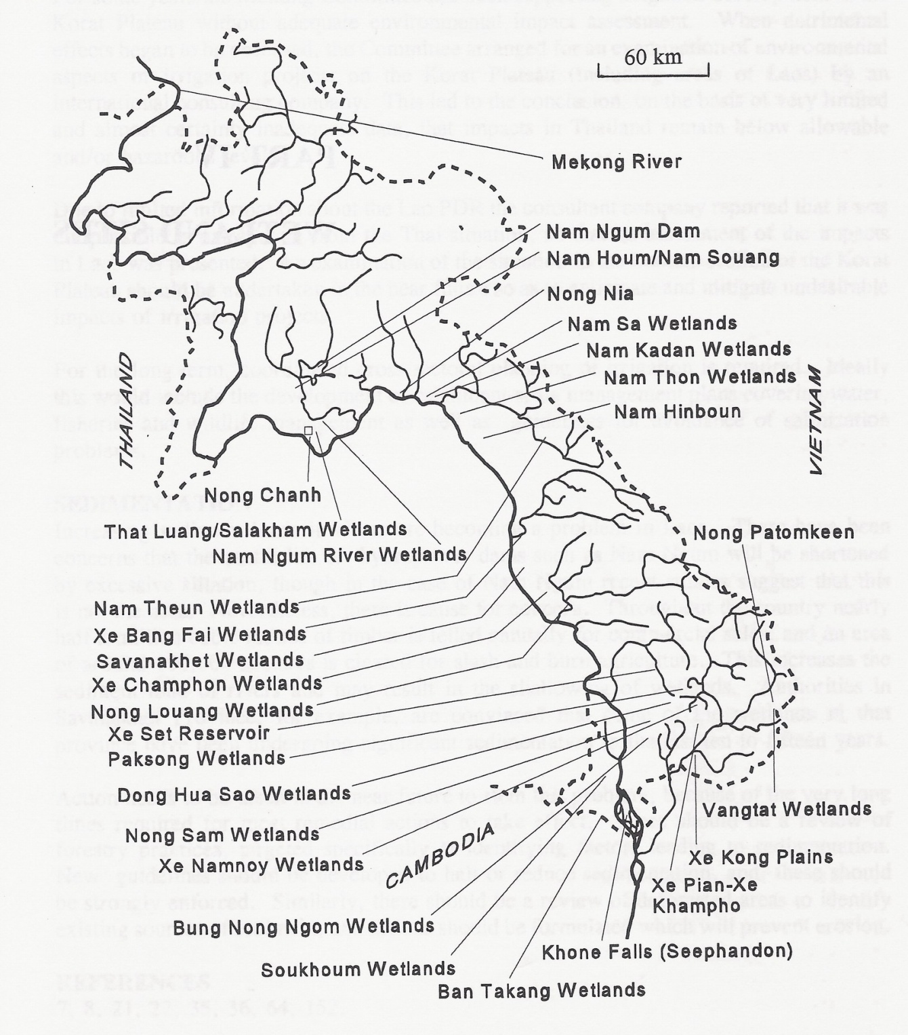

Sources: Gordon Claridge (1996), An inventory of wetlands of the Lao P.D. R

The non-fish refer to snails and frog which is the main income of villagers around the BKN
Vegetation refers to natural vegetation in the BKN, the main vegetation including morning glory and kangchong vegetation.
The estimation of opportunity cost for catching fish and non-fish are from the minimum wage in Participant Assessment Approach.
* This wetland inventory information below is quoted from Gordon Claridge (1996)

